
WHITE PAPER
A protocol for issuing a collateralised token
with a monotonically rising mint price
Version 2.6
11 September 2026 · assetrix.org

Contents

Executive summary

What this is
Assetrix is a protocol for issuing a collateralised token whose creation price rises monotonically and never falls. External assets are placed into a wrapper, entry into which becomes more expensive with every token issued.
By its founders' design the protocol forms a distinct class of crypto asset, which may be termed a ratchet — a coin with a rising issuance price. The definition refers solely to the price of creating new tokens, which is set by the protocol and does not decline. The market price of ASTRX has no bearing on this definition: it is determined by demand, is not guaranteed by the protocol and may fall.
The class is conceived as a complement to the stablecoin. A stablecoin holds its face value and with it loses purchasing power; here the entry price is tied to a rising quantity, while the collateral remains real and reclaimable at any time. The token is suited to payments and to trading on price differences. Risk-free saving is afforded by the position rather than the token: a position’s collateral is returned in full, whereas the token’s market price may fall towards the lower boundary of the corridor.

How it works
A participant deposits collateral and receives a position — a non-fungible token holding its own collateral. The position may be redeemed at face value or closed, issuing transferable ASTRX tokens backed by a share of the shared pool.
The protocol is non-custodial: collateral is held in the smart contract and may be reclaimed by its owner at any time. The market price of ASTRX is determined by utility value and lies within a corridor between backing per token and the current creation price; both boundaries are maintained by arbitrage.
Collateral is exogenous. Backing consists of external assets rather than the protocol's own token, so no mechanism for self-destruction of the reserve exists — in this the design differs fundamentally from algorithmic ones.

What the protocol does not do
The protocol creates no income from nothing and pays no interest. Collateral comes solely from participants, while growth in backing per token arises from fees and from the closing of positions created at a higher price. The protocol generates and promises no passive income.

Who governs
The protocol's parameters are governed by holders themselves. Subject to a vote are the fees that flow into the shared pool and work for the voters themselves, the depth of backing protection, the method of returning funds, the set of collateral currencies, the rate of increase of the issuance price and when the first phase ends. No protocol role can alter these values against holders' will, admit a collateral currency contrary to their decision, or halt the return of funds to participants.
The volume of issuance is regulated differently — not by vote but by participants' own decisions. The protocol issues no tokens at its own discretion: every token is created by whoever deposited collateral and disappears when someone reclaims it. If supply proves excessive and the price ceases to rise, participants redeem tokens; when the coin is in demand, they create new positions. The money supply follows market need directly, without an intermediary deciding on others' behalf.
The combination of the two circuits describes the design most precisely: an issuing centre whose governance is decentralised among the very people who use the coin it issues. Its parameters are set by their votes, its volume by their operations.

What the founders expect
As the market saturates, the inflow of new participants is expected to slow, and with it the growth of backing. A collapse of backing is nonetheless impossible by design: redemption is neutral to backing per token, so participants' departure reduces the pool's size but not the share of those remaining. The market price enjoys no such protection and may fall towards the lower boundary of the corridor.
Slowing growth, by design, itself creates the conditions for its resumption: some holders exit and later return, opening new positions at the increased price or acquiring tokens on the market. The design thus admits a self-oscillating regime in which expansion and contraction of the money supply succeed one another. Over a long horizon its growth is bounded by the growth of the external economy and of the market in those assets that serve as collateral.
The foregoing describes intent and mechanics, not a forecast: the market's actual behaviour depends on circumstances beyond the protocol's control.

1. Introduction

1.1. Protocol design
The protocol performs five functions: it creates positions in exchange for locked collateral, redeems positions and tokens returning collateral, transfers tokens between addresses, computes the current mint price, and accounts for holder votes when setting parameters.
The protocol holds participants’ funds itself: the collateral of positions and the balances of the shared pool. What is credited is what actually arrived rather than what the call declared — otherwise a token that withholds part of every transfer would leave a shortfall for whoever redeemed last.
Operation is divided into two phases. In Phase 1 the mint price is defined analytically and depends on the number of tokens issued. In Phase 2 it becomes a function of time and rises at a rate selected by a regulator.

1.2. Terminology
ASTRX — the protocol's transferable token, ERC-20 standard. Backed by a share of the shared pool. Used for payments, trading and governance. The market price of ASTRX is not guaranteed by the protocol and may fall; the property of risk-free saving belongs to the position, not to the transferable token.
ASTRX Position — a non-fungible token, ERC-721 standard, created upon depositing collateral. Holds its own collateral in its own currency. May be redeemed at face value or closed, issuing ASTRX.
Voting credits — units of voting weight accrued for a position closing that raised the pool's backing, in a quantity equal to the tokens received. Non-transferable; they diminish upon redemption and transfer of tokens.
Mint price — the amount of collateral in dollars required to create one new token within a position.
Book backing — the pool's aggregate collateral valued at the exchange rates prevailing at deposit, divided by circulating supply. Independent of subsequent rate movements.
Market backing (b) — the same pool at current rates, divided by circulating supply. Determines the amount received upon redemption and forms the lower boundary of the price corridor.
Phase 1 — the initial distribution period. Lasts until the hundred-millionth token is issued, or until early termination by holder decision.
Phase 2 — the regulated growth period. The mint price depends on time and rises at rate G.
Stage — one of ten intervals of Phase 1, each of 10 million tokens.
Epoch — the protocol's base time unit, 29,296 minutes. There are 18 epochs in a year.
Cycle — the decision application period, equal to two epochs. All parameter changes take effect simultaneously at the cycle boundary.
Growth rate (G) — the rate at which minting becomes more expensive, in annual per cent. Takes values from a fixed ladder from 5.6 % to 161.8 %.
Deadband — the threshold below which a decline in inflow is not deemed significant and the regulator does not act. Computed by the protocol from the measured volatility of inflow; not subject to a vote.
Protection level (X) — the admissible depth of decline in book backing from its historical maximum. Takes one of the values 23.6 %, 38.2 %, 50 %, 61.8 %.
Protection threshold (F) — the lower bound of book backing, equal to the historical maximum reduced by the protection level.
Active currency — a collateral currency subject to no restrictions whatsoever.
Guardian — the holder of the appointment key. Appoints and removes the operator, designates project wallets and adds shares in the distribution of remuneration.
Operator — the role appointed by the guardian, performing the protocol's operational actions.

2. Architecture
The protocol operates two entities of different natures. A position has individual collateral tied to the deposit made. The transferable token is backed by a share of the shared pool and is identical for all holders. Each entity is implemented by its own standard.
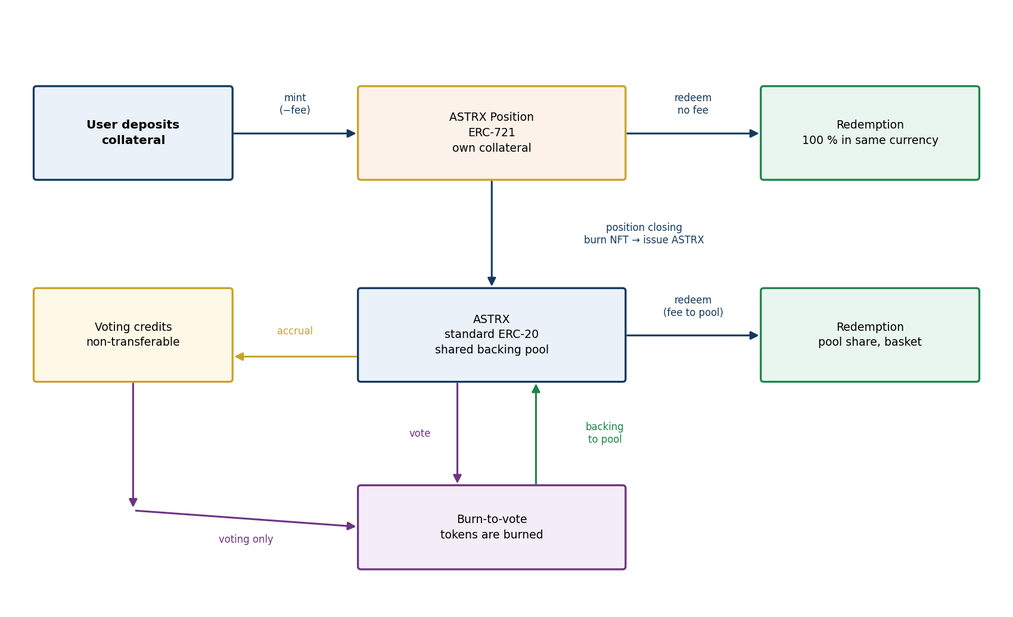
Fig. 1. ASTRX lifecycle

2.1. ASTRX Position
The position is implemented as an ERC-721 token. It stores the collateral currency, the amount deposited, the token count and the mint price at creation. The owner is stored separately, as the standard requires; the remaining fields as ordinary values.
Positions live in a contract of their own, for a technical reason that admits no workaround: ERC-20 and ERC-721 declare the same transfer event, where the third field is an amount in one and a token id in the other. A single contract cannot follow both. Renaming the event would compile and be useless — marketplaces and explorers look for exactly that signature, and a position nobody can list has no secondary market. The main contract therefore remains the ASTRX token, and positions are held separately.
- any number of positions in any currencies may be held at a single address;
- a position may be transferred to another party in its entirety, without conversion into ASTRX;
- redemption returns exactly the amount deposited, in the original currency;
- closing a position issues ASTRX and transfers the collateral into the shared pool.
Position redemption is never subject to a fee. This is the protocol's obligation to the position's creator and cannot be altered by vote or by any role's decision.

Splitting a position
The owner may split a position into equal parts — from two to a thousand. A thousand is the contract’s own limit; the practical one is lower and set by the network. At a block gas limit of thirty-two million a split runs out of gas at about two hundred and thirty parts, so a larger division is made in several operations. The original position is burned and a corresponding number of new ones is issued. Collateral and token count are divided equally; the cost basis and currency of every part are those of the original.
Parts are computed with rounding down and the last one receives the remainder, so the sum of the parts is identical to the original position. Each part must be no smaller than the minimum part size set for the currency at its admission, otherwise the operation is not executed. There is no partial redemption or closing of a position: the part required is separated by a split and redeemed or closed whole.
Splitting confers no advantage either on closing or in the accrual of credits. The cost basis of the parts equals that of the original, so the backing protection, the dilution fee and the accrual of credits apply to the parts exactly as they would to the whole.

Splitting is essential to the secondary market: without it a large position is indivisible and can only be sold in its entirety, sharply narrowing the pool of buyers.

The secondary market in positions
A position carries two quantities — collateral and cost basis — and both pass with it. This forms a market of its own, distinct from the market in the token.
A position's price is bounded below by its collateral: any lower and a buyer would do better to acquire and redeem it. Above, by the cost of closing — that is, how many tokens will be issued and at what price they can be sold. Between these bounds a position is valued by its cost basis: the lower it is relative to the pool's backing, the more tokens closing will yield.
The market provides an exit that does not touch the pool. A holder of a cheap position whose closing is constrained by the backing protection may sell it rather than wait. The constraint does not disappear — it passes to the buyer along with the position — but ceases to lock in any particular person.
Transferring a position is not subject to a fee: it affects the pool neither in the numerator nor in the denominator and therefore creates no backing-growth channel for which the token transfer fee exists.
Voting credits accrue to the party closing a position, not to its creator. Having acquired a position and closed it, a buyer obtains weight on the same footing as any other closer.

2.2. The ASTRX token
ASTRX is an ERC-20 token. At launch the transfer fee stands at the bottom rung of its ladder, which is zero, and the token is then an ordinary ERC-20: exchanges, wallets, bridges and aggregators handle it without special measures. Holders may vote the fee up, to at most one tenth of one per cent. Above zero a part of every transfer is burnt in flight, and the ordinary routes of the decentralised exchanges — which name a figure and require exactly that figure to arrive — no longer accept the token; selling and providing liquidity then go through a router written for the purpose, which pays the difference and holds nothing of anyone's. Withdrawing liquidity is an outflow and is never affected. Approvals may be given by signature (EIP-2612), so spending ASTRX through a pool or a router is one transaction instead of two.
Backing is shared across all tokens. Backing per token is identical for every holder and equals aggregate backing divided by circulating supply.

2.3. Voting credits
Credits carry no backing, are not transferable between addresses and are spent solely on voting. Their purpose is to involve in governance those participants who prefer not to expend backed tokens. They are awarded only for position closings that raised the pool's backing.

2.4. Operations
Operation | Content | Fee
Minting | Collateral locked, position issued | Protocol fee
Position redemption | Position burned, collateral returned in full | Prohibited permanently
Position closing | Position burned, ASTRX issued, credits accrued | When the floor is lowered
Position transfer | Standard ERC-721 transfer | None
ASTRX transfer | Standard ERC-20 transfer | By vote
ASTRX redemption | Tokens burned, pool share paid out | Non-zero, with multiplier
Voting | Function call, tokens or credits burned | None

The protocol does not convert ASTRX back into a position.

2.5. The position card
A position is represented in the participant's wallet by a card whose content is produced by the contract itself. The card's composition is part of the specification, since what a participant sees before transacting depends on it.
Fixed values: collateral currency, amount deposited, token count, cost basis per token, and the stage of creation.
Values computed at the moment of access: current backing per token and an indication of whether closing would lift backing or dilute it. From these a participant understands whether closing will be charged a fee or will earn credits — the main thing to know before the operation.
The image is composed by the contract when the card is read and is not written into the position’s storage: only the values listed above are stored, and the markup is assembled from them on request. It makes no reference to external storage, so the card remains legible for as long as the contract lives. The image reflects the currency, the size of the position and the standing of its cost basis relative to current backing.
In a wallet a position may be viewed and transferred — all that the standard provides for. Creation, splitting, closing, redemption and voting are performed through the protocol's interface.

2.6. Minimum operation sizes
Each position occupies protocol storage for as long as it exists. Without a lower size bound, storage could be flooded with numerous small positions, the cost of which falls on the network rather than the creator.
Operation | Minimum | Remainder rule
Position minting | 1 currency unit | —
Position redemption | — | whole positions only
Position closing | 1 token of the volume the protection permits | whole positions only
Position split | part minimum, set at admission | every part no smaller than the minimum

The amounts are set in units of the currency itself upon its admission, which avoids any reliance on price sources. For stablecoins one unit corresponds to one dollar. The minting minimum is checked against the deposited amount before the fee and surcharge are withheld, whereas the minimum part size on a split is measured on the collateral.
Flooding with a million positions at a one-unit minimum would require tying up a million dollars for as long as they exist, on top of irrecoverably spent gas. At one hundredth of a unit the same million positions would cost ten thousand.
The part minimum on a split is necessary, otherwise the ban on creating small positions would be circumvented by splitting existing ones. If the closing volume permitted by the protection falls below one token, the operation is refused outright rather than filled in part.

3. Mint price

3.1. Phase 1
The objective of Phase 1 is to attract participants and build the pool's backing within a short period. The mint price is defined analytically and depends solely on the number of tokens already issued. The initial value is $0.001 for the first token, the final value $200 for the hundred-millionth.
The count covers every token ever created, including the share withheld in payment of the protocol fee. Redemption of tokens and of positions does not reduce it, so the mint price does not fall under any outflow of participants. The issuance count does not coincide with circulating supply: backing per token is computed on circulation, the mint price on the count.
The rate of increase within the phase is uneven. It is highest at stages 1–3, when high returns are needed to attract attention; it declines at stages 4–6, when use of the token as a means of payment becomes the priority; and it rises again at stages 7–10, accelerating the accumulation of backing before the transition to Phase 2.
Within each stage the increase follows a cycloid whose convexity is always opposite to that of the envelope on that segment. Up to the fifty-millionth token the envelope is convex upward while the cycloids are convex downward; beyond it the reverse holds. The endpoints of each cycloid lie on the envelope.
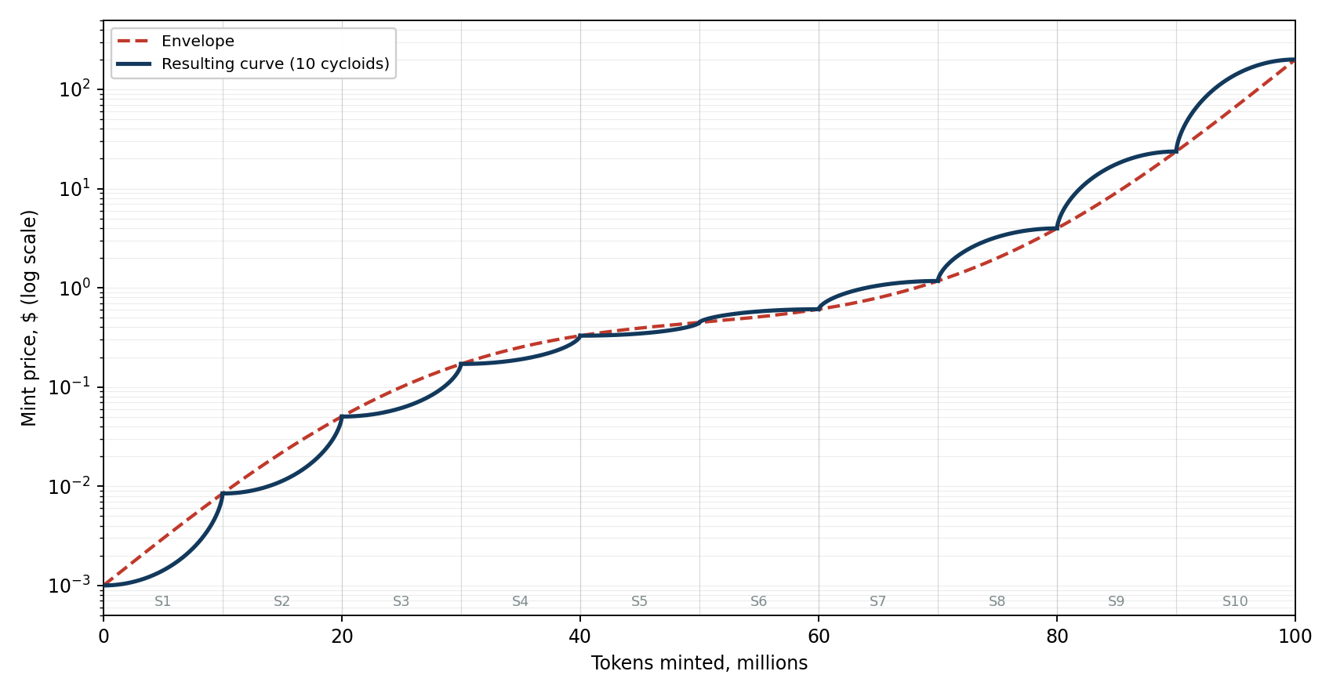
Fig. 2. Mint price in Phase 1
The envelope is defined on a logarithmic scale: the logarithm of the mint price rises at a rate proportional to 1 + A·cos(2πx), where x is the fraction of issuance completed and A = 0.80. The rate is thus highest at the start and end of the phase and lowest in the middle. The cycloid's shape is defined parametrically: the angle θ runs from zero to π, the stage fraction equals (θ − sin θ)/π, and the shape value equals (1 − cos θ)/2. Up to the fifty-millionth token the shape is mirrored so that its convexity opposes that of the envelope.
The formula is disclosed in full and deliberately so. The mint price is computed by the contract and is therefore reproducible from the bytecode in any event; concealing the formula would protect nothing while depriving a participant of the ability to verify what they pay before transacting.

On the shape of the curve
The shape of the Phase 1 curve serves the aim of creating varied opportunities for early participants: the alternation of fast and slow growth, and the change of convexity within each stage and across the envelope as a whole, leave room for saving, for arbitrage and for speculation alike. The market thus passes through several distinct regimes before reaching maturity.
The possibility of levelling the distribution of capital across stages was examined by calculation. Reducing issuance changes the proportions not at all: stage shares coincide to the digit, since tokens contract proportionally. Lowering the final mint price tenfold shifts the last stage's share from 85.8 to 78 per cent, that is, it reduces the capital required but does not remove the disproportion — which is set by the shape of the envelope rather than by scale.
The high final price and the concentration of capital in the last stage are not regarded as a shortcoming. The curve describes the upper bound of the possible path rather than a mandatory route: from the fourth stage holders may terminate Phase 1 at any time, and the portion actually traversed is decided by the inflow and by them.

Early transition to Phase 2 is possible by vote. The reference point is fixed when the issuance counter first enters the fourth stage; from that moment voting is open and the result applies at cycle boundaries, as it does for every other subject.
This subject used to be tied to the stage rather than to the cycle, and that proved to be a way in. Stages advance on the issuance counter rather than on time, and a single large mint may cross a whole stage: a vote and the mint that crossed the line fitted into ONE TRANSACTION, so anybody could vote and step over the threshold in the same breath, with no one able to answer. On the cycle grid there is no such moment — a vote is stamped with its own cycle and is read only at the following boundary.
The transition is one-way. A vote against it once made returns nothing: Phase 2 is not left. The reason is the one under which the protocol has no wind-up procedure at all — an irreversible lever under a vote demands a confidence that voting by burning cannot give while circulation is small.

3.2. Phase 2
In Phase 2 the mint price becomes a function of time and is recomputed continuously in accordance with the prevailing growth rate. There is no step: a step would create a moment before which it pays to hurry in, the same objection under which the redemption multiplier is continuous. Nor could a step be aligned with the epoch: 29,296 minutes factors as 2⁴ × 1831 with 1831 prime, so the nearest divisors are sixteen minutes and thirty and a half hours.
The growth rate takes values from a fixed ladder built on Fibonacci extensions: 5.6 %, 9 %, 14.5 %, 23.6 %, 38.2 %, 50 %, 61.8 %, 100 %, 161.8 %. The step between adjacent values is close to 1.618 over most of the ladder. The exception is the 50 % step, added for a smoother movement of the regulator in the middle of the ladder where it operates most often: the transitions 38.2 → 50 and 50 → 61.8 give 1.309 and 1.236. The steps are taken as the familiar retracement levels rather than computed as a geometric progression.
The ladder's minimum is 5.6 % per annum and never becomes negative. The lowest step serves not merely as the least admissible rate: Phase 2 begins at it, an exhausted traversal of the regulator returns to it, and it is the natural anchor for a holder voting in manual mode without a view of his own. It is therefore aligned not with the risk-free return, which would suit a measure of cost, but with the rate at which the coin remains distinguishable from a stablecoin.

3.3. Time model
The mint price curve is defined in token numbers and does not by itself determine timing. The aggregate capital required to issue one hundred million tokens is $1.54 billion — the integral of the curve. Its distribution is highly uneven: the final stage accounts for 85.8 % of the total, the first seven for less than 1.5 %.
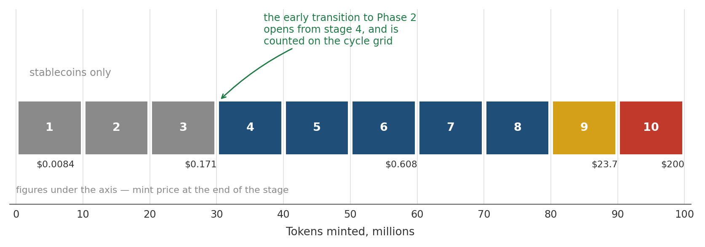
Fig. 3. The stages of Phase 1 against the issuance counter
Stage | Duration | Completion | Mint price at end | Stage capital
1 | 4.0 epochs (81 d) | 0.22 yr | $0.0084 | $20.1k
2 | 10.7 epochs (219 d) | 0.82 yr | $0.050 | $148k
3 | 12.0 epochs (244 d) | 1.49 yr | $0.171 | $719k
4 | 9.2 epochs (187 d) | 2.00 yr | $0.329 | $2.04M
5 | 6.2 epochs (126 d) | 2.35 yr | $0.447 | $3.56M
6 | 4.9 epochs (100 d) | 2.62 yr | $0.608 | $5.65M
7 | 4.7 epochs (96 d) | 2.88 yr | $1.17 | $10.07M
8 | 6.8 epochs (138 d) | 3.26 yr | $3.97 | $30.5M
9 | 11.1 epochs (226 d) | 3.88 yr | $23.7 | $165.0M
10 | 15.3 epochs (312 d) | 4.74 yr | $200 | $1,320.2M

The timings in this table are highly provisional. The duration and completion columns derive from an assumption of exponential inflow growth, calibrated so that Phase 1 fits into 85 epochs. Actual inflow will differ and timings will shift non-linearly. Stage capital, unlike timings, does not depend on assumptions: it is the integral of the curve. Where redemptions occur part of the path is traversed twice, so the figures should be read as a lower bound.

The aggregate figure of $1.54 billion represents the full cost of traversing the entire curve and is not a condition for the protocol's viability. From the fourth stage holders may terminate Phase 1 early; by its beginning accumulated capital amounts to roughly $887 thousand.
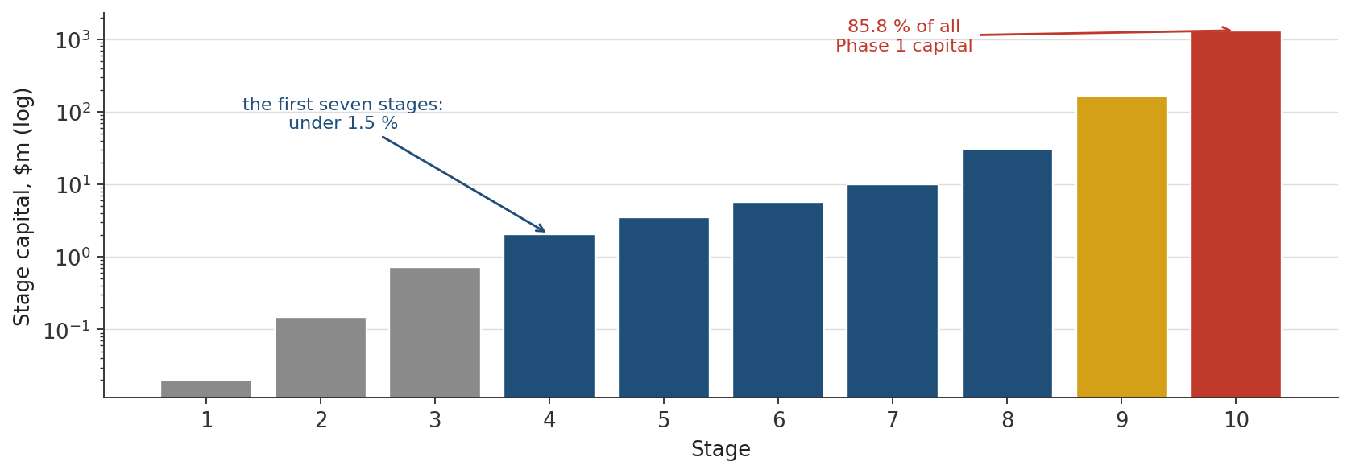
Fig. 3a. Where the capital of Phase 1 sits

3.4. Price corridor
The protocol does not set the market price of ASTRX and cannot set it. It sets two other figures, and the market price lies between them: below, the backing — the share of the reserve that falls to one token; above, the cost of entry — the price at which the contract mints a new token.
The lower level is held up by redemption. It is open at all times: a holder exchanges tokens for a proportional share of the reserve, less the redemption fee, whenever he likes. This is not an undertaking to buy the token back at some price but a consequence of the design — the reserve belongs to the holders, and the way out of it does not close under any circumstance. Should the market price fall below backing by more than the fee, buying the token on the market and redeeming it in the protocol becomes profitable.
Backing per token can fall for two reasons: because there are more tokens without collateral to match, and because the collateral itself has fallen in price. Against the first the protocol protects literally. With a reserve of stablecoins the protection level set by the community holds as written: backing does not go below that share of its historical maximum, and no sequence of operations, no number of addresses and no splitting changes that. At the default value the fall does not exceed 61.8 per cent of the record; at the strictest available, 23.6 per cent.
The second reason is the risk of the collateral itself. Where participants deposit volatile currencies the protection weakens: it holds backing relative to the reserve, and the reserve is measured in what sits in it. The asset falls, and the level below which the protocol will not let backing go falls with it. The protocol does not remove that risk, but it softens it: with the volatile-collateral spread, with the concentration surcharge whose reference is 30 per cent of volatile assets and whose cap is 60, and with a live valuation of the reserve at prevailing quotes, so that the protection responds to a fall at once rather than after the fact.
Backing also rises of its own accord: the dilution fee is withheld in tokens and never enters circulation, the transfer fee and every vote cast are burned, and the rounding in every operation goes the way that is safe for the reserve. The mint price never falls, so whoever enters later does not enter cheaper than whoever entered before.
The upper level is held up by the availability of entry. Anyone may enter at any time at the mint price the contract computes for itself, so there is no reason to pay substantially more for a token on the market than entry costs.
How fast that upper level may rise is set by the contract. In Phase 1 the path of the cost of entry is predetermined by the curve and ends at 200 dollars per token. In Phase 2 the cost of entry grows with time, at between 5.6 and 161.8 per cent a year; the rung in force is moved by the regulator according to inflow, or directly by a vote of the holders should the community take the rate into its own hands.
Both figures are ceilings on the cost of entry, not a return. Two hundred dollars and 161.8 per cent a year describe how fast entry into the protocol may grow dearer, and say nothing about what a holder will receive. The figure that actually applies depends on the behaviour of the system as a whole and on which parameters the community votes for. Where the price sits inside the corridor is settled by the market, and the protocol does not interfere with it.
The market price of ASTRX is determined by its utility value and lies within a corridor whose boundaries are maintained by arbitrage. The upper boundary is the mint price: above it, creating new tokens is cheaper than buying them on the market. The lower is backing per token: below it, redeeming a token is preferable to selling it.
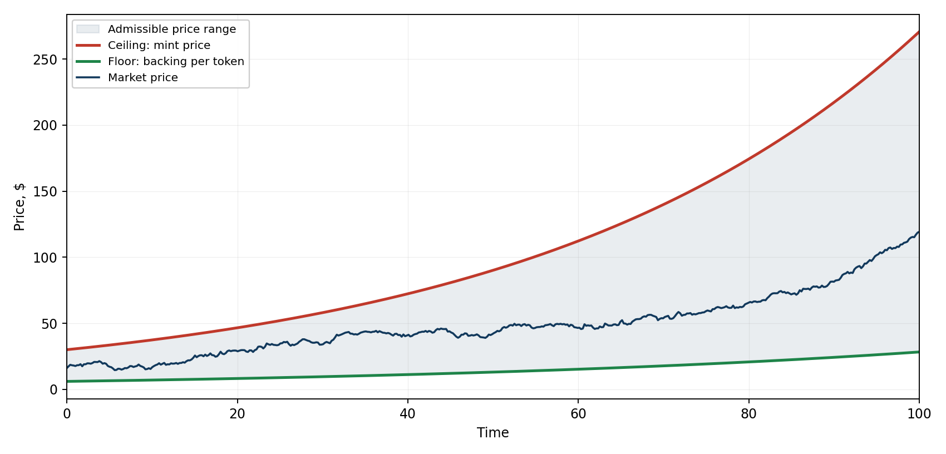
Fig. 4. Price corridor
Creating a position entails no nominal loss under any circumstances: the deposited collateral is returned in full. Minting therefore remains rational even when the market price is below the mint price — the participant creates a position in anticipation of the future. The cost is not the risk of loss but the opportunity cost of capital.

3.5. Trading on decentralised exchanges
While the transfer fee stands at the bottom rung of its ladder, which is zero, nothing in this section applies: the token moves like any other, and the ordinary interfaces of the decentralised exchanges serve it without help. What follows describes what changes if the holders vote the fee above zero.
A pool on a decentralised exchange never looks at what reached it. It names a figure and then requires its own balance to have risen by at least that much. Hand over exactly the figure named, and part of it is burnt on the way; the pool comes up short and the operation is refused. Neither side is at fault: the pool is counting correctly and the token is behaving as described. The way through is to hand over enough that the named figure arrives in full — the requirement is “at least” rather than “exactly”, so a payer who covers what will be burnt satisfies it. Nothing is asked of the pool, nothing is added to it, and no exchange need know anything of the protocol; the whole accommodation lives in the payer’s code.
Nor can it be arranged from behind the pool. Uniswap v4 allows hooks — pieces of code the pool calls as it works — and such a hook was written and tried on the live network. It does shift the debt, but it still cannot close the sum: the payer’s own transfer happens after every hook has returned, and no hook reaches that far.

Buying and selling
Buying never fails. What goes in is an ordinary token, and the pool asks nothing of the buyer beyond it; the ASTRX comes out through a transfer like any other, so the buyer receives slightly less than the pool sent. There is nothing to compensate and no router is needed, though a router may still be used to keep one interface for both directions.
Selling is where the ordinary route fails, and where the router earns its place. The seller names what leaves his balance, the burnt share included: that is the figure he approves, and the figure the router will not exceed. On v3 the router tells the pool the smaller figure — the one that will actually arrive — and hands over enough for it to arrive. On v4 the order is reversed: the router pays first, then asks the singleton to swap exactly what it received, so no arithmetic is needed at all. Either way the seller sells a little less than he named, and the difference is what was burnt.
The approval may be given by signature rather than by a separate transaction, which turns a sale into one transaction instead of two. The signature is attempted rather than required: it sits in the open before it is mined, anyone may spend it first and for nothing, and a sale that insisted on spending it itself could be blocked by a single cheap transaction.

Liquidity on Uniswap v3
Here the pool asks whom the position should be credited to, and payment is made afterwards, in a callback. The router therefore names the depositor as the owner and pays the compensation itself: the position is his from the first moment, and the router holds nothing belonging to anyone. Taking the liquidity back needs no router at all — the pool hands it to whoever owns it, and handing over is an outflow, which is never checked against a fee. A position opened while the rung stood at zero survives the holders later voting the fee up.

Liquidity on Uniswap v4
Uniswap v4 works differently. It does not ask whom a position should be credited to: the position belongs to whoever opened the lock. That is why Uniswap ships a position manager of its own — it keeps the positions and issues each depositor an NFT, a token of ownership that can be transferred or sold. For ordinary tokens the arrangement works perfectly well.
It does not suit this token, and for a single reason. The manager names an exact figure and moves it itself, letting nobody in while it holds the lock. Less arrives than was named, the debt to the pool stays open, and the operation fails. This is a measurement rather than an argument: the same deposit was run on the live network, and at the zero rung it goes through and the position is written to the depositor, while above the zero rung it is refused.
The obstacle is a narrow one. It lies neither in v4 nor in any property of the token, but only in who conducts the settlement. When we conduct it, what will be burnt is covered with a margin and the surplus reclaimed in the same operation — and liquidity goes in at any rung of the fee. This already works: it is how the protocol’s own tests seed a v4 pool.
Assetrix therefore plans a position manager of its own, on the same model as Uniswap’s and with one difference: it covers what is burnt. It opens the lock, settles with the compensation, and issues the depositor the same kind of NFT, against which he later withdraws his liquidity. Until it exists, liquidity on v4 is added through the ordinary Uniswap interface while the transfer fee stands at zero; such positions survive the fee being raised, because withdrawal is an outflow and outflows are not checked.

What is published alongside the protocol
Assetrix publishes two auxiliary contracts alongside the protocol: a router, and a position manager for v4. Neither is part of the protocol. They hold no rights over the core, are not counted among its contracts, and anyone who writes better ones is free to replace them: the core neither knows of them nor names them. The router is written and has been tested against the live Uniswap deployments. The position manager is not yet written — it is planned, and this passage should not be read as describing something that exists.

4. Collateral

4.1. Admitted assets
The composition of collateral at launch is fixed by a list at the moment of deployment and from then on changes only by decision of the holders: new currencies are announced by the operator from stage 4 and connected by vote (§4.4). The reserve currencies described below enter the launch list dormant.
Asset | Issuer | Supply on the deployment network
USDC | Circle | ≈ $2.2 billion
USDT | Tether | ≈ $840 million
PYUSD (candidate) | PayPal | ≈ $185 million
USDS (candidate) | Sky | ≈ $100 million
DAI | Sky | ≈ $19 million

The figures show supply on the network where the protocol is deployed rather than issuers' global capitalisations: what matters is the volume available on that network, since it alone bounds inflow and determines the reserve's actual shares. On deployment to a different network the set is revised, as canonical addresses and liquidity differ.
PYUSD and USDS are listed as candidates: at the time of writing neither has a quote source on the deployment network, and without one a currency is not admitted as collateral. They will be connected in the ordinary way — announced by the operator and voted in by the holders — as soon as a source appears.
A currency is defined by its contract address, not by its symbol. Two contracts carrying the symbol USDC exist on the deployment network: the native one issued by the issuer, and a bridged one that arrived over a crossing. They are different assets with different risks, and the native one is admitted.
Issuers of centralised stablecoins have the technical ability to blacklist addresses. Should the vault address be blacklisted, collateral in that currency would become inaccessible. This argues for the permanent presence of decentralised assets in the reserve.

4.2. Reserve currencies
Wrapped ether (WETH) and wrapped bitcoin (WBTC) enter the launch list dormant: they are admitted to the protocol and their properties are fixed at deployment, but deposits in them are not accepted until the operator wakes them. The protocol accepts ERC-20 tokens only, so the wrapped forms are what enter it, not the assets themselves.
The purpose of this construct is the protocol's ability to continue operating should centralised stablecoins become unavailable. The power is an exception to the general rule that the operator may not admit a currency against holders' will; there is no contradiction, since approval was granted in advance and recorded in the protocol by the launch list itself.
Both reserve currencies are woken by separate operator decisions. The supply of wrapped bitcoin on the deployment network falls short of that of ether, so waking the former warrants greater caution.
Waking a reserve currency changes the character of market backing for all holders: from that moment it follows the exchange rate of the woken asset, whereas previously it consisted of dollar-pegged assets. The pace of this transition is limited by the surcharge on the volatile share rather than by a prohibition: minting in a reserve currency is never suspended at any value of the share.
It is essential that the custodian of wrapped bitcoin and the operator of the deployment network are distinct parties. Were they the same, the reserve currency would fail together with the network and would not serve the fallback role for which it was introduced.

A dormant place in the launch list is the only way a volatile currency can appear in the collateral before stage 4: announcements of new currencies open only from there. Otherwise the protocol would be left without a fallback in precisely the most vulnerable period.
The staleness limit is set per currency, at the moment it is admitted. A single figure cannot serve: sources do not stream, but write a value when the price departs beyond a threshold or when their own update interval elapses, and that interval differs between assets and even for one asset across chains. A common limit would be either too lax for a volatile currency or shorter than a stablecoin’s own interval — and then a perfectly healthy source would read as stale and halt the protocol for nothing.
The state of the deployment network’s sequencer is checked separately. While it is down no operation reaches the chain, and every quote keeps the value it had when it stopped: fresh by its timestamp and dead in fact. The reserve is not valued during that time, and after it resumes an hour’s grace applies — the queue that built up executes first, and participants must have time to react before their positions are judged on prices that moved all at once.
A stablecoin that has drifted below the dollar is taken at what it is worth, not at par. That removes the transfer of loss at any depth of depeg: whatever value a participant brought, that is what is credited. The earlier rule barred deposits beyond a nine per cent departure but let everything short of the threshold through AT PAR — so at 0.95 the transfer existed, merely smaller.
Above par a cap applies. A depositor would be handing the protocol the difference, so nobody deposits an expensive stablecoin: no prohibition is needed, the thing is unprofitable in itself. The cap also guards against a quote spiking upward, whether from a broken source or a passing premium. Volatile currencies have no par, and are valued at their rate in both directions.
Silence from a source and failure of a source are not the same thing. A feed being replaced, or briefly out of touch, is far commoner than a depeg, and halting the protocol for a day over a missing write costs more than the price error it avoids.
A quote therefore has three states. While the source answers and the answer is fresh, its price is used. If a stablecoin has been silent for less than a cycle it is valued at par: valuation of the reserve, both redemptions and voting go on, while minting and closing in that currency stop. If the silence runs longer than a cycle — or if the currency is volatile and has no par — it goes dark: it takes no part in the valuation, backing is reckoned on the larger of the visible pool and the book value, and minting and closing in it stay stopped.
Minting and closing are carved out of the middle state not out of caution. They are the two operations by which one participant's loss becomes everyone's: depositing a depegged currency at par, or moving it into the shared pool by closing, buys tokens below their value, and the difference is paid by every existing holder. Redemption carries no such transfer — it hands out the basket as it is.
Both redemptions work in all three states. Neither reads quotes at all, so neither a silent source, nor a failed one, nor a halted sequencer touches them.

4.3. Reserve concentration surcharge
Reserve concentration creates two risks. Dominance by a single issuer means that blacklisting of its addresses would affect most of the backing. Dominance by volatile assets means that exchange-rate movements would shift the market backing of all holders.
The protocol does not obstruct any operation on these grounds. Instead of a restriction, a surcharge is applied to the fee when minting in a currency that reinforces the imbalance. The surcharge is withheld from the deposit and passes in full into the shared pool without issuing new tokens.
The surcharge is computed by the protocol at the moment of the operation and is not stated by the participant. A figure named by the depositor himself would be a discount he had granted himself. It is computed on the reserve THE DEPOSIT WILL MAKE, the deposit counted in: priced on the reserve as it stands, the deposit that creates an imbalance would pay nothing for creating it and the charge would fall on whoever came next.

4.3a. Spread on volatile collateral
A deposit in a currency that is not a stablecoin is valued at a discount. The figure is set by a vote of the holders from the series 0, 3.4 and 5.6 per cent; the middle rung applies by default. The vote is on a scale: votes are cast to widen or narrow the spread by one rung per cycle. A median count would let a single cycle carry the spread down to nothing, and this is a guard on backing rather than a charge in anyone’s favour; it should not be undone at a stroke.
The spread lowers the valuation of the deposit, not the collateral itself. The pool keeps the whole asset while issuing tokens for a smaller sum, and the difference remains as backing for every holder. It is a buffer against a volatile asset falling, built up by those who deposit such assets.
Depositing and redeeming the position straight back is neutral: the redemption returns the same collateral, untouched by the spread. It bites only on closing — that is, when volatile collateral actually turns into backing for the rest.
The spread does not repeat the concentration surcharge. The surcharge responds to the state of the reserve and falls to zero when the composition is balanced; the spread responds to the nature of the asset and is charged always. At the maximum of both a volatile deposit gives up about eight per cent.
Metric | Benchmark | Limit | Maximum surcharge
Share of a single issuer | 35 % | 76.4 % | 0.56 pp
Share of volatile assets | 30 % | 60 % | 2.36 pp

The share is computed by issuer rather than by asset ticker. Two stablecoins from one issuer constitute a single risk: blacklisting of its addresses affects both, so their shares are added together. In the current set this applies to USDS and DAI, issued by the same ecosystem.
The surcharge is zero while the share does not exceed the benchmark, then rises linearly to the limit and remains at the maximum thereafter. Minting never ceases at any value.
The benchmark and the limit are chosen separately and on different grounds. The benchmark marks the point from which the protocol begins to signal and is therefore set low: were an issuer to hold half the reserve, its blacklisting would remove half the backing. The limit marks the point of saturation and is placed above the market's actual concentration so that the mechanism retains room to respond to further deterioration rather than merely levying a constant charge at its ceiling.
The surcharge's steering force is modest: a participant holding only one currency will pay it and proceed. The principal instrument for balancing concentration is the choice of redemption method.

4.4. Admission and suspension of currencies
From stage 4 the operator may put any ERC-20 token to a vote. The decision rests with holders; a currency cannot be admitted against the vote. The announcement enters into the protocol the currency's address and all of its properties — the issuer, the quote staleness limit, the minimum sizes, the stablecoin and volatility marks; holders vote on the currency together with its terms, and while the currency is in service the terms do not move. From the announcement a vote opens, closing at the nearest cycle boundary no sooner than one full epoch later. No more than twelve announcements await a decision at once. A currency the vote declined, or one disconnected later, may be announced again — on fresh terms and with a fresh vote.

Currency use ban
A currency may become compromised without loss of reserve — through significant depreciation, legal proceedings against the issuer, or other circumstances casting doubt on its suitability. A ban is then imposed covering simultaneously the minting of new positions using that currency and the closing of existing positions with such collateral.
These restrictions are never imposed separately: banning closure without banning minting would mean letting participants in but not out.

The ban may be imposed in two ways: by holders through a vote, or by the operator with immediate effect subject to subsequent verification by vote; until the holders lift it, the ban stands. Redemption — of both positions and tokens — remains available at all times under a ban. On token redemption the banned currency leaves the reserve first: whole, under the most-capitalised method; and under the basket with a skew towards it of up to 161.8 % of its proportional share (§5.2).
If the vote does not confirm an operator-imposed ban, it may be re-imposed after one epoch. If holders upheld the ban, no re-vote is held: the currency can return to circulation only through a fresh announcement and the full admission procedure from the start.

4.5a. Migration of a collateral currency
The address of a deployed contract never changes, but an issuer may deploy a new contract at a new address and declare the old one deprecated. The "same" currency is then at a different address while the old one remains in the reserve. This has already happened on the deployment network.
The loss flag will not serve here: it means the reserve is gone, and writing it down to nothing would be untrue — a deprecated token is usually redeemable with its issuer one for one long afterwards.
The order is different. The operator bans the old address: minting and closing in it stop, both redemptions go on. At the same time the new address is announced and the holders vote it in. The old token drains out of the reserve through redemptions: a banned currency is paid out first under the most-capitalised method and with a skew of up to 161.8 % of its share under the basket; at a quarter of the reserve and under the most-capitalised method the reserve is clear of it in about five epochs. The holders verify the ban, and the currency is disconnected for good.
Backing does not move meanwhile: the token is paid out at what it is worth, not written down. Under the proportional basket the draining is slower, so on a migration the community would do well to switch the payout method — that vote is available from the start.

Protection of the initial set
Disconnecting a currency by vote is impossible before the start of stage 4 — and since new currencies are announced only from there, the whole launch list is protected. The rationale is the vulnerability of the early period: backing is still small at that time, making governance weight inexpensive.
The protection applies only to voluntary suspension by vote. Emergency procedures — a compromise ban and recognition of reserve as lost — operate from the outset without restriction.

Minimum number of active currencies
The number of active currencies cannot fall below three as a result of a vote. If at a cycle boundary a majority for suspension is reached for so many currencies that fewer than three would remain active, those with the larger absolute vote margin are suspended first, and only until three currencies remain active. In the event of an equal margin, the currency with the larger share of the reserve is retained.
The minimum of three currencies is chosen so that the community retains room to suspend: with five admitted stablecoins, two of them may be suspended by vote. Dormant currencies do not count as active until woken. It should be understood that where one issuer predominates, protection against freezing is provided not by the number of nominally active currencies but by the presence in the reserve of assets with no freezing mechanism.
The number of collateral currencies is capped at twelve. The cap exists not to save room: every admitted currency adds a step to the pass over balances performed on minting and on closing, and so costs every participant more for ever, not only at the moment of connection. Twelve leaves five places beyond the present composition and nine for disconnection.
The rule constrains voting, not reality. Emergency procedures are not subject to it: if issuers have frozen the remaining currencies, the protocol reflects the resulting impossibility. In such a state minting is impossible or available in a single currency only, while redemption operates as usual.

4.5. Loss of reserve
Part of the reserve may become inaccessible — for instance if the vault address is blacklisted by an issuer. Awaiting a vote in such a situation is unreasonable: the inaccessible asset would continue to participate in backing calculations and in the payout basket, distorting them. The reverse order therefore applies: the operator acts immediately, and holders confirm or cancel the action.
The write-off is applied simultaneously to market and to book backing: the book value loses exactly what that currency contributed. Simultaneity is essential: an entry left in place would be a phantom — the backing record, which is kept on the book figure, would climb on collateral that is gone. The historical maximum is not reset: the record never falls (§8.6). The protection threshold stays where it was in dollars per token while backing falls by the depth of the loss — after a loss the protection is stricter and the exit dearer (§7.2) until backing has grown back.
If the holders lift the flag, the currency's book entry returns in its former amount and everything is restored exactly: an erroneous exclusion erases nothing.
The loss flag never lowers the threshold, not for a moment. Otherwise setting it would open a window in which dilution passes and stays irreversible even if the flag is later lifted. Only the holders can lift the flag, by vote; until they do, it stands.

Verification of actual availability
If the vote removes the flag, the operator may not re-impose it for twenty-four hours. If after the removal at least one hundred units of that currency have actually left the protocol account, the bar on reimposition extends to the nearest cycle boundary after those twenty-four hours.
Only a completed transfer to a participant counts. A successful redemption is direct proof that transfers execute, and substitutes for any judgement by the parties as to the asset's availability.

Simultaneous compromise and loss
A currency may be both compromised and frozen; both flags then act at once: minting and closing are prohibited, the reserve is excluded from backing calculations, no payout in that currency is made upon token redemption, and position redemption is permitted where technically feasible.

4.6. Price data
Price data is sourced from industry-standard decentralised oracles. The protocol verifies the freshness and validity of the values received; if a source is unavailable, operations depending on it are suspended until data is restored. No role may enter rates by hand.
A currency for which no price source of adequate quality exists on the deployment network is not admitted as collateral.
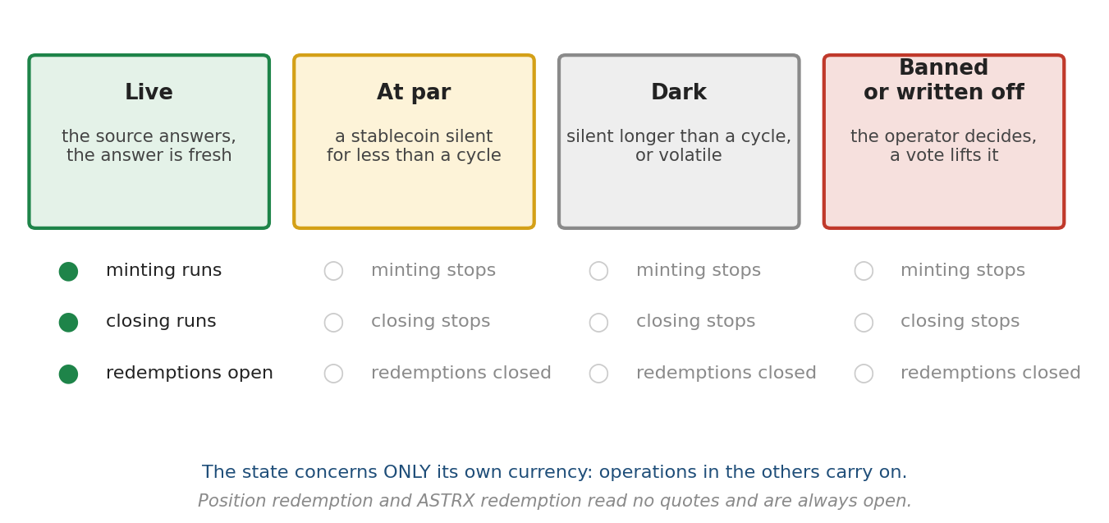
Fig. 9. A currency's state and what it allows

4.7. Valuation of the reserve
The pool holds balances in each admitted currency rather than a single dollar sum. Two distinct quantities are derived from those balances.
The live value is the sum of the balances converted to dollars at the prevailing quotes. Everything describing the present state is computed from it: backing per token, the protection headroom, and the payout on redemption.
The book value is the sum of the dollar valuations fixed at the moment each deposit entered, reduced on redemption by the same share as the basket. It is never revalued.
The two coincide while rates stand still and diverge when they move.
The separation is deliberate. The live value reflects reality but depends on quotes and is therefore exposed to a single error of the source. The book value is immune to such an error: the entry was made in the past and does not change retroactively. The present state is therefore computed from the live value, and only the backing record (§8.3) from the book value — the record never decreases and would otherwise remember an error for ever.
A consequence to be accepted deliberately: a reserve currency losing its peg immediately lowers backing per token. The protocol sees the loss of reserve at the moment it happens rather than when the redemption queue reaches it.
The alternative — computing backing on the book value — does not remove the loss but merely decides who pays it. Under book valuation the first to redeem receive their claim in full and the shortfall falls entirely on the last; backing, meant to reassure, thereby begins to hurry. Under live valuation the loss is shared evenly among all holders and the order of redemption decides nothing.

5. Redemption

5.1. Position redemption
The owner receives exactly the amount deposited, in the same currency. The position is burned whole; to redeem a part, it is first separated by a split (§2.1). No fee is charged under any circumstances.
Position redemption makes no reference to quotes: the same currency and the same amount that were deposited are returned. The operation is available whatever the state of the data sources.

5.2. ASTRX redemption
The holder receives a share of the pool balances proportional to the tokens presented relative to circulating supply. Backing per token rises slightly: the fee withheld stays in the pool and accrues to the remaining holders.
Two methods of selecting the payout currency are provided; the one applied is determined by vote and takes effect at the start of the following cycle.

Proportional basket
The payout is a cross-section of the pool across all currencies in their current shares, every currency however small its balance. The reserve structure is preserved automatically and the outcome does not depend on the timing of the request. One departure: while the reserve holds a currency on its way out — banned, or disconnected by vote — and quotes are live, the slice is skewed towards it, up to 161.8 % of its proportional share, so that its share falls with every redemption without waiting for inflow. The cap exists so that the first redeemer is not paid wholly in the unwell currency; with dead quotes no skew is possible and the plain slice applies.
The plain slice requires no quotes. The holder’s share is determined by the ratio of the tokens presented to circulating supply and is applied to each balance separately; price plays no part in that computation and can therefore neither distort the result nor halt the operation. The property is essential: redemption is the token holder's only exit, and it must work when data sources are unavailable.

Most-capitalised currencies
The payout is made in one of the currencies with the largest volume. Currencies differing in volume by less than 5.6 per cent form a group within which payouts rotate. The ranking is computed off-protocol and supplied within the transaction. The protocol verifies the full ordering of the sequence provided: each currency appears exactly once and volumes are non-increasing. A partial check would be insufficient — it would permit reordering within a group and thereby selecting the payout currency.
The order of traversal within a group is set by the protocol and does not depend on the sequence submitted. Checking the ordering is not sufficient for this: with equal volumes any permutation passes the check honestly, since the sequence is indeed non-increasing either way. Were the group assembled in the order submitted, the sender would select the payout currency himself by swapping equal rows.
The case is not marginal. The group exists precisely to combine currencies of similar volume, and levelling the reserve is the stated purpose of this method. The closer the reserve is to the levelled state for which the method is enabled, the more often volumes coincide and the more often the ordering check ceases to constrain anything.
The most-capitalised method consults quotes twice: to verify the ranking, since volumes of different currencies are comparable only in a common unit, and to compute the payout amount. It is therefore unexecutable when the quote of even one admitted currency is unavailable.
In that state token redemption executes as a proportional basket, regardless of the method chosen by vote. The switch happens inside the operation itself: it changes no protocol state and revokes no vote. As soon as quotes are restored, payouts return to the chosen method without any action by roles or holders.
The asymmetry is deliberate. Suspending minting defers an entry, suspending closing defers an optional operation, and both are cured by waiting. Suspending redemption would lock a holder into an asset he has decided to leave, and waiting does not cure it: the protocol does not know when the source will return. Redemption by basket needs no valuation at all, which is why the fallback path exists for it alone.
The choice of method is the principal instrument for managing reserve concentration. The basket leaves the reserve structure unchanged, whereas the most-capitalised method levels it. At a redemption turnover of six per cent of the pool per epoch, this method reduces the dominant currency's share from ninety to fifty per cent in approximately forty epochs, while the basket leaves it virtually unchanged.

Currency unavailability during payout
Time elapses between the actual freezing of a currency by its issuer and the setting of the loss flag by the operator. A transfer in such a currency fails, and the redemption reverts as a whole: the protocol does not guess which currency let it down, and does not pay out the others while leaving the question of the missing one open.
There are two ways out, both explicit. The first is the loss flag from the operator: a written-off currency is paid nothing, no transfer in it is attempted, and the redemption goes through in the rest. The second lies with the redeemer: he may name currencies whose share he waives. That is needed also when the issuer has blacklisted not the protocol's vault but the holder's address: the currency is sound, no flag is on it, but this particular person cannot receive it. Under the basket the waived share stays in the pool and goes to the other holders; under the most-capitalised method the claim moves to the next currency in the ranking less 38.2 per cent of the amount moved — otherwise waiving would be a way to choose the payout currency, which is exactly what the ranking check forbids.
A loss flag is not set automatically upon a failed transfer: the transfer may fail owing to a restriction on the recipient's side rather than the protocol's vault, and these cases cannot be distinguished within the contract. The decision stays with people: the operator sets the flag if the vault is unreachable; the holder waives his share if he himself is.

Waiving a share under the basket is a loss to the redeemer bounded by the weight of that currency in the basket: at a quarter of the reserve, about a quarter of the claim.
Banned and disconnected currencies are withdrawn first under the most-capitalised method; the basket is skewed towards them within the limits described above.

5.3. Rounding
All rounding favours the pool: downward on payouts, upward on accruals. This precludes the gradual erosion of backing through repeated small operations.

6. Protocol issuance fee
The fee is charged only upon creating a position and constitutes remuneration to the founders for developing the protocol. The protocol imposes no obligations regarding its expenditure.
On depositing collateral of V, at a fee rate s and a concentration surcharge u, the participant receives a position of V·(1−s−u) divided by the mint price, while the project receives V·s divided by the mint price in ASTRX, backed by the collateral share V·s which passes into the shared pool. Both quantities are computed from V independently of one another, so the stated percentages mean exactly their share of the deposit and the result does not depend on the order of computation. The surcharge passes into the pool without issuing new tokens.
The backing of these tokens equals the current mint price, hence necessarily above the pool average. Every fee withholding raises the backing of all holders. No unbacked tokens arise within the protocol.
The fee tokens are issued by a separate operation within minting rather than by closing a position. This matters: a closing with cost basis above backing is rewarded with voting credits and is subject to the minimum size, whereas the fee issuance yields no credits and is not subject to the minimum closing size.

Period | Maximum rate
Phase 1, stage 1 | 1.0 %
Phase 1, stage 2 | 1.2 %
Phase 1, stage 3 | 1.4 %
Phase 1, stage 4 | 1.6 %
Phase 1, stage 5 | 1.8 %
Phase 1, stage 6 | 2.0 %
Phase 1, stage 7 | 2.2 %
Phase 1, stage 8 | 2.4 %
Phase 1, stage 9 | 2.6 %
Phase 1, stage 10 | 2.8 %
Phase 2 | 0.56 %

The rate rises by 0.2 percentage points at each subsequent stage. In Phase 2 it is lower than any Phase 1 rate, since the project's income is weighted towards the initial distribution period, when the principal work of launching and promoting the protocol is performed.
The figures given are ceilings fixed in the contract code. The operator sets the prevailing rate within these bounds and may assign any lower value down to zero; the ceiling cannot be exceeded by the operator, the guardian or a holder vote — this constraint is immutable.

The prevailing rate is exposed by the protocol for reading at any time, and changes to it emit events, so the project's actual policy is observable and verifiable independently of any statements.

6.1. Distribution
The fee accumulates at a single treasury address. Rights to it are divided into shares whose number changes under a set procedure: at deployment there is one share tied to the guardian's address, who may add a new address, thereby increasing the number of shares. The maximum number of shares is one hundred.
An added address cannot be removed under any circumstances by anyone, including the guardian. The fee is distributed among the shares existing at the moment of withholding; previously accumulated amounts are not recalculated.
Each withholding updates a single value — accumulated income per share. A shareholder may claim at any time, and the protocol pays the difference between the current value and that at their last claim. Transfer costs are borne by the recipient.

7. Fees in favour of holders
In addition to the protocol fee, there are fees that pass into the shared pool and raise the backing of all holders.
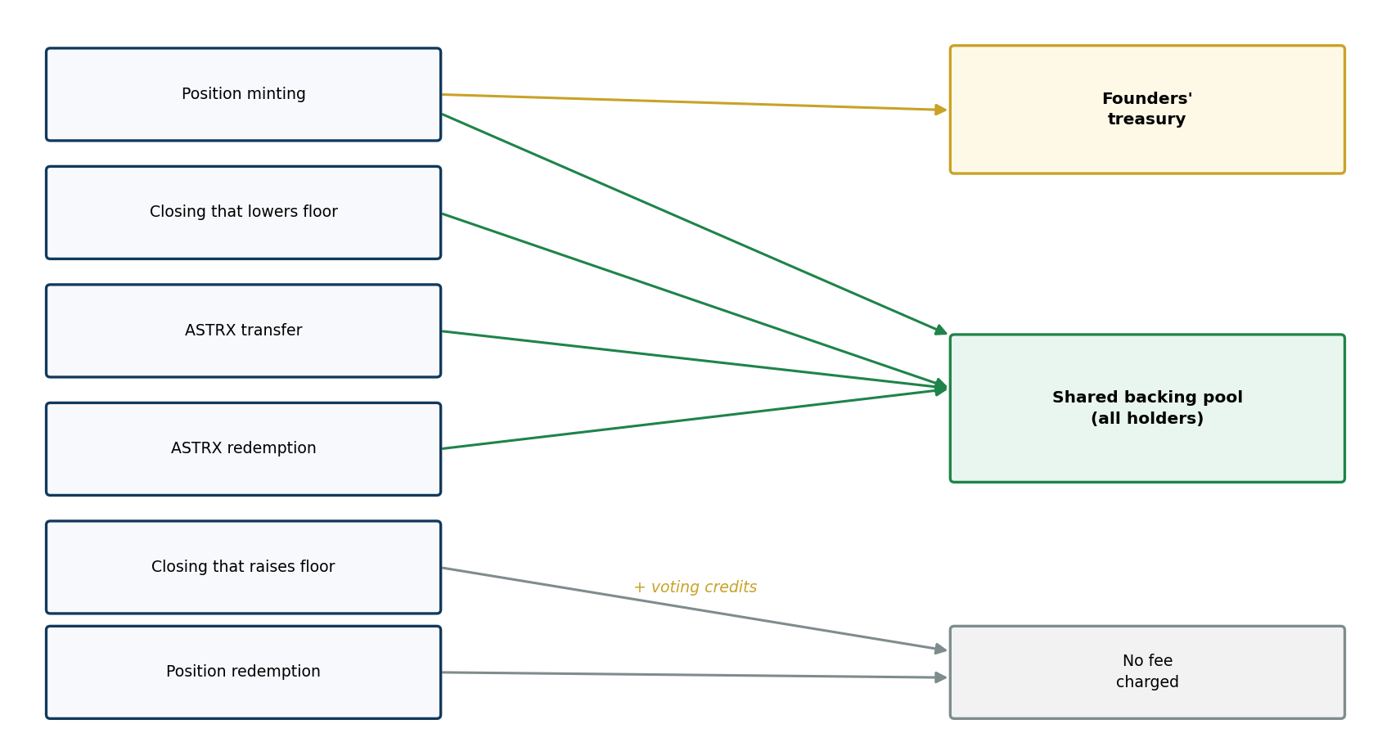
Fig. 5. Fee flows

7.1. Economic rationale
The principal channel for backing growth is the closing of positions created at a high mint price. However, closing occurs when the market price is sufficiently high, that is in a favourable market phase. During stagnation this channel is largely inactive.
Redemption and transfer fees operate independently, and work the harder the greater the outflow of participants. They work counter-cyclically: the backing of those remaining grows precisely when the market is weak.

7.2. Redemption fee multiplier
The redemption fee is multiplied by a factor depending on the current drawdown of book backing relative to its historical maximum. The multiplier equals one divided by one minus the drawdown.
Backing drawdown | Multiplier | Value
0 % | 1.000 | base fee
23.6 % | 1.309
38.2 % | 1.618 | the golden ratio
50 % | 2.000
61.8 % | 2.618 | the golden ratio squared

The multiplier equals the factor by which backing must grow to return to its historical maximum. The cost of exit is thus proportional to the depth of the pit from which those remaining must climb.

The mechanism's purpose is to retain pool volume during drawdowns. The larger the pool, the smaller the share any single dilutive closing represents, so retained volume itself reduces the sensitivity of backing to subsequent dilution. The multiplier is not an instrument for restoring backing: its contribution to growth amounts to fractions of a percentage point per year.
The multiplier is continuous and has no steps, so it creates no point ahead of which holders would rush to exit. No separate cancellation procedure is needed: as backing recovers, it returns to unity of its own accord.

7.3. Position closing fee
Position closing is distinguished by its effect on the pool. If the position's cost basis exceeds book backing, the closing raises the backing of all holders; such an operation is never subject to a fee, and this rule is not amendable by vote.
Moreover, a closing that raises backing is not merely exempt from a fee but is rewarded with voting credits equal to the number of tokens received. One and the same comparison — the position's cost basis against book backing — determines both the sign of the effect on the pool and whether the operation is rewarded or charged.

If the cost basis is below backing, the closing dilutes the pool. The fee is then proportional to the depth of dilution and equals k multiplied by one minus the ratio of cost basis to backing. It is withheld in tokens: fewer ASTRX are issued to the closer than the position contained, while the collateral passes into the pool in full. There is nothing else to take it from — at a closing the whole collateral already goes to holders.
Position cost basis | Gain from closing | Dilution fee at k = 5.6 %
0.9 of backing | 10 % | 0.56 %
0.5 of backing | 50 % | 2.8 %
0.1 of backing | 90 % | 5.0 %
0.01 of backing | 99 % | 5.5 %

Proportionality is necessary because the closer's gain is itself proportional to this quantity; a flat rate of fractions of a per cent against a ninety per cent gain means nothing. The coefficient k takes values from the ladder 5.6 %, 9 %, 14.5 %, 23.6 %, 38.2 %; a zero value is unavailable.
This form of withholding has an exact property. The value of the fee at current backing equals k multiplied by the closing volume and by the difference between backing and cost basis, while the damage to other holders equals that same product without the coefficient. The fee therefore returns to the pool exactly the k-th share of the damage done, at any depth of dilution — and this is the ground for the proportional form.
The fee does not fully eliminate the incentive to dilute: even at its maximum the closer retains most of the gain. It complements the backing protection by returning part of the damage to the pool, but does not replace it. A useful side effect: the higher the coefficient, the more attractive redemption becomes relative to closing for a holder of a cheap position — and redemption does not affect the pool at all. The coefficient has a second function as well: since the fee is withheld in tokens, for the same volume of tokens entering circulation the overhang is consumed 1/(1−k) times faster — at the maximum value about 1.6 times. The fee thus does not weaken the protection but accelerates the retirement of the overhang.

7.4. Voting credits
Credits accrue on closing a position whose cost basis exceeds book backing — that is, on a closing that raises the backing of other holders. The number of credits accrued equals the number of tokens received from that closing.
No credits accrue for a dilutive closing. Nor do they accrue for the payment of any fees.

Depletion
Credits are non-transferable and are spent solely on voting. They diminish proportionally upon redemption of tokens and upon transfer of tokens to another address — at the sender, with no accrual to the recipient. They do not fall below zero and no negative balance accumulates.
The rule is simple: weight is retained while the tokens remain with the holder and disappears when they part with them. Where the tokens went — sold or redeemed — is immaterial.

Depletion is necessary because the mint price rises. Without it, credits obtained early in the protocol's life would retain full weight at a time when acquiring the same weight costs orders of magnitude more, and the governance share of participants who have left would grow over time rather than dilute.

What the weight reflects
Weight obtained through credits reflects early participation rather than the size of the contribution. This follows from the design: for an equal deposit, the token count is greater the lower the mint price was when the position was created.
A numerical example. The pool holds one hundred tokens with backing of three hundred dollars, that is three dollars per token. Participant A closes a position with collateral of five dollars created at a mint price of five dollars; participant B closes a position with collateral of fifteen dollars created at a price of fifteen dollars. Each position consists of one token, so each receives one token and one credit.
Participant | Collateral | Given to others | Price of one vote
A | $5.00 | $1.98 | $1.98
B | $15.00 | $11.86 | $11.86

A threefold larger deposit yielded the same single vote at six times the cost. The property is deliberate and coincides with the one governing the token price itself: whoever entered earlier receives more for the same money. To require that weight be distributed on a different principle from tokens would be inconsistent.

Robustness to splitting
The number of credits equals the number of tokens and is therefore strictly additive. Closing a position in full, closing it in a hundred parts, and closing the parts from different addresses all yield the same number of credits. Splitting confers no advantage under any order of operations or number of participants.
The property is essential: quantities computed through the increment in backing are not additive, since backing grows non-linearly, and sequential closing in parts would yield a different result from closing in full.

Relation to burn-to-vote
A vote through credits and a vote through burning cost differently, and this should be acknowledged plainly. Burning costs the full backing per token and is the same for everyone. A credit is obtained by raising the floor on closing, and its price depends on how far the position's cost basis exceeded backing.
No holder is deprived of a vote: burning is always available to anyone. Whoever has closed no positions, or has spent their credits through transfers, pays the ordinary price for a vote.

7.5. Exit from a position
A position has two exits, and they obey different rules. Redemption returns the position's collateral and looks only at who owns it: no vote, no operator and no guardian may cancel it, suspend it or defer it; a ban on the currency and a loss flag do not reach it; and it reads no quote at all, so it survives both a silent price channel and a halted sequencer. What it returns is the collateral of the position — that is, the deposit less the issue fee and the concentration surcharge, both withheld at minting and not at the exit.
Closing turns the position into tokens and its collateral into part of the common pool. There is no way back: a token does not become a position. Closing is refused if the currency is banned or flagged as lost, and it is limited in volume — but only for positions whose cost basis lies below the protection threshold.
The difference between the two is not one of convenience but of what each does to the pool. Redemption takes the same share of every balance and leaves the composition untouched: it costs the pool nothing. Closing a cheap position issues tokens against collateral that does not cover them, and so lowers the backing of everyone else. It is that which is limited.

How the limit works
Backing has a record, a figure that never falls. Below the record lies the protection level, set by a vote of the holders; what results is the threshold. The distance between present backing and the threshold is the shared headroom.
A position whose cost basis stands above the threshold meets no gate: it closes whole and at any time. A position below the threshold passes only in a volume that leaves backing above the threshold, and a single closing is passed not the whole headroom but a share of it — 38.2 per cent.
The refusal is not partial. A position exceeding the permitted volume does not close for the permitted part but is refused entirely; to take what is permitted it is divided into parts and closed one at a time. Splitting neither evades the limit nor widens the headroom — it only makes it possible to take what the limit allows.

Capacity from one record
The full headroom accumulated to a single record is a multiple of the tokens already in circulation, and the multiplier is set by the protection level chosen: 0.309 at 23.6 per cent, 0.618 at 38.2, 1.000 at 50, and 1.618 at 61.8.
Two consequences follow, and both matter. The headroom grows with circulation, so it is smallest exactly when unissued cheap positions are most numerous — early in Phase 1, while nobody has closed and the only tokens in circulation are the fee tokens. An early position in that period may be several times the whole circulation and not pass the gate at all.
The headroom is replenished only by backing rising to a new record, and what raises it is other participants' minting: the issue fee enters the pool at the current price, which is always above the pool's average. But only the fee with its surcharge enters the pool, not the whole deposit — the collateral of a new position lies within that position. Replenishment is therefore slower than the inflow by orders of magnitude.

The headroom is shared
It belongs to the state of the pool, not to a position and not to its owner. Holders of cheap positions draw on one and the same headroom, and order matters. Whoever closes earlier narrows the passage for the rest, and narrows it substantially: a position equal in size to the one that passed first may afterwards be refused entirely. The contract hurries nobody — a position has no term, no storage charge and no decay — but neither does it reserve a place in the queue.
A holder the gate refuses is not trapped. Redemption is open to him always and returns the collateral of the position in full.

8. Protection of backing against dilution

8.1. Pool protection at launch
When the pool is small, a single operation can substantially shift backing per token. Protection is implemented by a virtual offset: in computing backing, a constant equivalent to one hundred dollars is added to the numerator and one hundred thousand tokens to the denominator. Their ratio equals the initial mint price, so the proportion is undistorted and the offset acts purely as a damper.

8.2. Nature of the risk
The value of ASTRX does not equal its backing but is determined by utility value and market pricing. Nonetheless backing is an important parameter whose dynamics indirectly indicate the state of the market, and measures against its abrupt decline are therefore necessary.
The mechanism operates on both valuations of the reserve introduced in §4.7. The backing record is kept in book terms and therefore remembers no quote error; the threshold, measured down from the record, is revalued together with the basket, so a change of rates neither widens nor narrows the volume a close may take. When a position is closed its collateral passes into the shared pool; the closing raises backing if the cost basis exceeds the current value and lowers it if below. The latter case is termed a dilutive closing.
The risk arises not from the shape of the curve but from the property of a rising price itself: positions are created at ever higher prices, yet they are not all closed and not closed at once, so a gap opens between the cost basis of old positions and current backing. The shape of the curve sets the size of that gap rather than its origin — the path from $0.001 to $200 makes it as wide as possible, a gentler curve would make it moderate. The first seventy million tokens — 70 % of Phase 1 issuance — are created at a cost of $22.21 million, giving an average cost basis of 32 cents against a final mint price of $200.
The overhang is not consumed in a random order. The gain from closing equals the difference between backing and cost basis, so the propensity to close cheap positions first is higher. Propensity, however, is not predetermination: the holder of an expensive position bears the cost of waiting, since collateral earns nothing; backing and still more the market price do not move monotonically, and on declines closing may be preferable to holding regardless of cost basis; participants differ in horizon and tolerance of drawdown. The order in which the overhang is washed out is therefore skewed towards cheap positions but not fixed by them — and the protection is needed precisely because the skew exists, not because the order is known.
Overhang, share of circulation | Backing after | Decline
0.25 | 0.800 of former | 20.0 %
0.5 | 0.667 of former | 33.3 %
1.0 | 0.500 of former | 50.0 %
2.0 | 0.333 of former | 66.7 %

The damage depends not on the absolute size of the overhang but on its share of circulation: if an overhang of near-free tokens amounting to a share f enters circulation, backing is divided by one plus f. This measure does not depend on scale and connects directly with section 8.4, where the limiting admissible injection is expressed in the same share of circulation.
The threat is a diminishing one rather than permanent: the overhang decays through three independent channels. The first is closing at an opportune moment; only this one strikes the pool, and the protection exists for its sake. The second is redemption of a position out of weariness of waiting; it is neutral to backing, since the collateral was never in the pool and will not enter it, and for those remaining this is the best outcome. The third is attrition by growth: the overhang is a fixed number of tokens while circulation grows, so its share falls of its own accord. The overhang need not be consumed — it is enough to outgrow it.

8.3. Design of the protection
The protocol stores the historical maximum of backing computed on the book value of the reserve. The value updates on every operation that changes backing and never declines. The protection threshold equals that maximum, reduced by the protection level and brought to the current value of the basket by the ratio of its live value to its book value.
The threshold and the pool are revalued by one and the same multiplier, so a change in the rates of reserve currencies shifts the protection in neither direction: depreciation of a collateral currency does not block closings, and its appreciation does not widen them. Dilution is measured against the reserve as it stands. The loss from depreciation is not thereby hidden — it is visible in backing per token and is realised on redemption, which pays out a share of the basket by its actual composition.

On closing a position the value of its collateral at the moment of closing, divided by the number of tokens, is taken; call it c. The cost basis recorded on entry will not serve: the collateral enters the pool at the current rate, and what actually enters is what should be compared with backing, else a position in a depreciated currency counts as non-dilutive while being dilutive.
There are two boundaries, and they answer different questions.
Volume is limited by the threshold. If c is not below the threshold, the closing executes in full; if c is strictly below the threshold, no more than a fraction q of the headroom divided by the difference between the threshold and c is executed.
Credits and the fee are decided by backing. If c is not below backing, the closing is non-dilutive: it earns voting credits and bears no dilution fee. If it is below, the fee applies.
A single branch on backing would send positions lying between the threshold and backing into the limited path, where the difference between the threshold and c is negative and the closing would be refused outright. Yet such a closing is safe: it lowers backing but does not reach the threshold.
Headroom is the amount of backing present in the pool above the minimum required to hold the threshold. It is neither stored nor allocated as a quota, but recomputed before each operation. The fraction q is 38.2 per cent and is fixed in code: it is not subject to a vote, and the constraint only narrows the admissible volume and hence cannot weaken the protection.
The case of cost basis equal to the threshold is treated as the first: such a closing brings backing towards the threshold but never breaches it. Separate handling is required since the denominator would otherwise be zero.
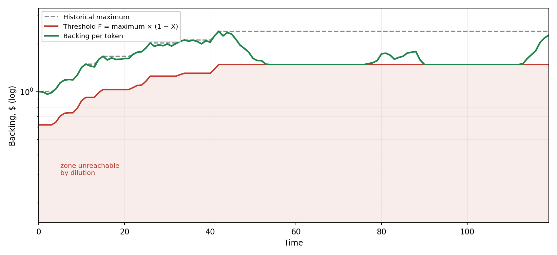
Fig. 6. Backing protection

Asymptotic approach to the threshold
The fractional constraint changes the mechanism's character. Each operation takes only part of the headroom, so the remainder decays geometrically with ratio 0.618: after ten operations about 0.8 per cent of the original headroom persists. Backing approaches the threshold asymptotically and does not reach it in a finite number of operations.
Applicant | Without fraction limit | With 38.2 % fraction | Headroom remaining
first | entire headroom | 38.2 % | 61.8 %
second | nothing | 23.6 % | 38.2 %
third | nothing | 14.6 % | 23.6 %
tenth | nothing | 0.50 % | 0.81 %

The ratio of the volume available to the first applicant to that of the tenth falls from unbounded to seventy-six. In practice dilution ceases before the headroom is exhausted: at some step the permitted volume falls below the minimum closing size.

8.4. Meaning of the protection level
The level admits an exact interpretation independent of assumptions about participant behaviour. The limiting volume of near-free tokens that may enter circulation with the pool's backing unchanged equals X·S divided by one minus X.
Level X | Limiting injection | Interpretation
23.6 % | 0.309 of circulation | strict
38.2 % | 0.618 of circulation | moderate
50.0 % | 1.000 of circulation | lenient
61.8 % | 1.618 of circulation | catastrophe protection only

The ratios form the golden sequence 0.309 — 0.618 — 1.000 — 1.618, a property of the retracement ladder itself carried through a linear-fractional transformation.

The quantity is a limit, not a one-off opportunity: given the headroom fraction constraint it is approached only asymptotically. One operation yields 38.2 per cent of it, two 61.8 per cent, five about ninety.

8.5. Schedule of available levels
Period | Available levels | Method of setting
Stage 1 | 61.8 % | by default, no vote
Stage 2 | 61.8 %, 50 % | vote
Stage 3 | 61.8 %, 50 %, 38.2 % | vote
Stages 4–10 | 61.8 %, 50 %, 38.2 %, 23.6 % | vote
Phase 2 | all four | vote

Voting is incremental: votes are cast to shift along the ladder towards leniency or strictness by one step per cycle. Smoothness matters here, since abrupt tightening could leave backing below the new threshold.

8.6. Changing the protection level
Tightening raises the threshold and may leave backing below the new threshold; dilutive closings then halt until backing recovers. This is an intended consequence: halting dilution is precisely what the community seeks by tightening the level.
The historical maximum is not reset upon tightening. Such a reset would produce the opposite result: at a maximum of 10 and backing of 5, moving from level 61.8 to 38.2 per cent would lower the threshold from 3.82 to 3.09, weakening protection precisely when the community sought to strengthen it.

The historical maximum is never reset, including on a loss of reserve (§4.5): on a loss the written-off currency's contribution leaves the book value while the record stays, and the protection is only stricter for it.

8.7. Properties
Closings cannot create a block, and this is demonstrable: since each operation takes only a fraction of the headroom, the headroom remains strictly positive for any number of operations, and a fraction of a positive quantity is positive. Only an external event can push backing below the threshold — a loss of reserve deeper than the protection level, or a tightening of the level (§8.6); such a block is lifted not by the passage of time but by the growth of backing: lifting closes, the redemption fee, which is never zero, burning on transfers and votes. Both redemptions stay open throughout.

The volume admitted by the protection is taken in the order transactions arrive; the order within a block is determined by the sequencer, so where the headroom is exhausted the advantage falls to whoever came first. Splitting an operation or using multiple addresses does not raise the limit: the volume of tokens able to enter circulation while the threshold is held is fixed by an identity and does not depend on the number of applications. Only the speed of approach changes — each subsequent call recomputes the admissible volume from the updated state, so several calls take more than one does. The limit nonetheless remains the same, and the threshold is not breached at any number of them.
Ordering within a block matters. Headroom is allocated in order of arrival, and the fractional constraint mitigates this substantially, yet competition persists. Its consequences differ fundamentally from the analogous phenomenon on exchanges: there participants' haste itself moves the price and accelerates reaching the threshold, whereas here total dilution is bounded by the headroom regardless of how many apply. Competition determines who dilutes the pool, not how deeply.

9. Governance

9.1. Casting a vote
A vote is cast by calling a protocol function specifying the subject, the side and the amount. Tokens or credits are burned at the moment of the call. The backing of burned tokens remains in the pool and is distributed among the other holders: burning gives the vote a real price, excluding costless influence, while simultaneously raising everyone's backing.
Two counting methods apply. Binary, with sides designated For and Against, decides whether an event occurs. Median, where holders cast votes for specific ladder values, is used to set quantities: the weighted median prevails.
Median counting is preferred to a simple majority because, with dispersed opinions along an ordered ladder, a majority may elect an extreme value, whereas the median is robust to vote fragmentation. The exception is the protection level, set by incremental voting with a one-step shift per cycle.
There is no quorum and no supermajority: the side that burned more wins. A quorum guards against a cost-free vote deciding for a silent majority, and here a vote is not cost-free — it costs the full backing of the tokens burned, and that cost is paid to every other holder. Nor does a quorum act as a barrier: it is a price, not a prohibition, and whoever will burn five per cent will burn ten.
Against an unopposed decision the protection is the window. A vote runs to the cycle boundary, some forty days, and objecting costs exactly as much as proposing. Votes do not carry between cycles: otherwise any threshold would be reached eventually at any turnout.
Where weight falls exactly evenly on two adjacent rungs of a ladder, the median takes the higher — the direction that favours the pool, as every rounding rule does.
Votes are accepted right up to the cycle boundary. A later voter has fuller information about the emerging outcome, yet the price of a vote does not depend on when it is cast: it equals book backing per token and is the same in the first block of the cycle as in the last.

9.2. Governed parameters
Subject | Frequency | Default | Available from
Early transition to Phase 2 | Each cycle | Negative | Stage 3
ASTRX redemption method | Each cycle | Basket | Start
Protection level | Each cycle, incremental | 61.8 % | Stage 2
Transfer fee | Each cycle, median | 0 % | Start
Redemption fee | Each cycle, median | 0.9 % | Start
Dilution coefficient | Each cycle, median | 5.6 % | Start
Growth-rate control mode | Each cycle, priority | Automatic | Phase 2
Rate in manual mode | Each cycle, median | — | Phase 2
Admission of a collateral currency | Upon announcement | — | Stage 4
Currency ban, verification | Upon operator action | — | Start

10. Growth-rate regulation

10.1. Market condition indicator
Market condition is assessed by a single indicator — the inflow of funds into position creation, measured in dollars at the rate prevailing at each operation. The collateral of positions redeemed in the same cycle is subtracted from inflow; closing a position is not subtracted, since on closing the collateral does not leave the protocol but passes into the shared pool. Inflow accumulates over a cycle and is compared with the preceding cycle. The comparison is made across the cycle boundary: the preceding cycle was lived at the former rate and the current one at the new rate, so their ratio retains precisely the action of the rate. Comparing two epochs within one cycle is unsuitable for this: both run at the same rate, and its influence cancels in their ratio.
A single indicator is chosen because inflow is linked to the growth rate directly. Indicators reflecting reserve size depend on numerous extraneous causes, and their joint use would require weighting coefficients that cannot be determined by calculation: they express a value judgement about the project's priorities rather than a measurable quantity.
Collateral of positions redeemed within the same cycle is excluded from the accumulated figure. Both quantities are taken at book value, so the offset is exact and rate movements do not affect the indicator. The exclusion is necessary because position redemption bears no fee and returns exactly what was deposited: without it, the cycle of creating a position, awaiting measurement and redeeming would allow an arbitrary fictitious inflow to be presented to the regulator at the cost of the protocol fee alone.

Position closings are not deducted from the indicator, for two reasons. The first: on closing, funds remain within the protocol, moving from the position into the shared pool, so the inflow is genuine. The second is more substantial.
Closing a position costs the closer the difference between its cost basis and the pool's backing, and that difference passes irrevocably to the other holders. With a pool of one million tokens at backing of thirty dollars and a mint price of one hundred, closing a position of one million dollars leaves the closer about a third of what was contributed: they give the others some sixty-nine per cent of the sum. Against one per cent in fees this is sixty times more expensive.

Presenting the regulator with a fictitious inflow by way of closing is therefore not merely expensive but ruinous, and there is no need to deduct closings. The funds spent on such an attempt pass in their entirety to holders.

10.2. Deadband
A decline in inflow is deemed significant only if it exceeds the deadband. The deadband is neither a constant nor put to a vote: it is a technical parameter whose meaning cannot be a matter of collective judgement, and at the same time a quantity dependent on the current volatility of inflow.
The protocol computes it autonomously. A moving average of the absolute relative change in inflow between adjacent cycles is maintained; the deadband is defined as one minus the exponential of minus 2.06 times that average. The cadence of measurement and the cadence of comparison coincide deliberately: the threshold must be set against the dispersion of the same quantity it cuts off, otherwise it is displaced by a factor of the order of the square root of two.
The rule's meaning is simple: the deadband equals the customary amplitude of inflow fluctuation. The regulator responds when a decline exceeds the usual spread and does not respond within it. The coefficient is derived rather than fitted: the requirement is that false triggering not exceed five per cent.

Inflow dispersion | Measured average | Deadband | False triggering
0.15 | 0.121 | 22.0 % | 4.9 %
0.30 | 0.248 | 40.1 % | 4.5 %
0.45 | 0.393 | 55.5 % | 3.9 %
0.70 | 0.697 | 61.8 % | 9.3 %

The rule holds the target up to a dispersion of about 0.45; above it the upper bound of the deadband becomes binding and the share of false triggering rises. Bounds are set: the deadband may be no narrower than 5.6 per cent and no wider than 78.6 per cent — the latter being the square root of 0.618, a level of the same series as the other parameters. At the start of Phase 2 no history exists, so until four cycle observations have accumulated a starting value of 78.6 per cent applies — the upper bound of the deadband. Absent any knowledge of volatility the regulator thereby stays silent rather than firing to no purpose; as observations accumulate the deadband narrows of its own accord.

10.3. Automatic mode
The underlying postulate: it is unknown whether the growth rate should be raised or lowered, and prior experience does not indicate which. The fact that an increase helped in the past does not mean the same action will reproduce the result.
The protocol therefore keeps no memory of the direction of past steps; upon detecting a significant decline in inflow it probes the ladder sequentially, diverging from the current position alternately in both directions until it finds a value at which inflow resumes growth. The side on which the traversal begins alternates from one probing to the next: an unvarying start with an upward step would impart a systematic upward bias, and where the response of inflow is shallow the regulator would drift towards the upper steps contrary to the indicator.
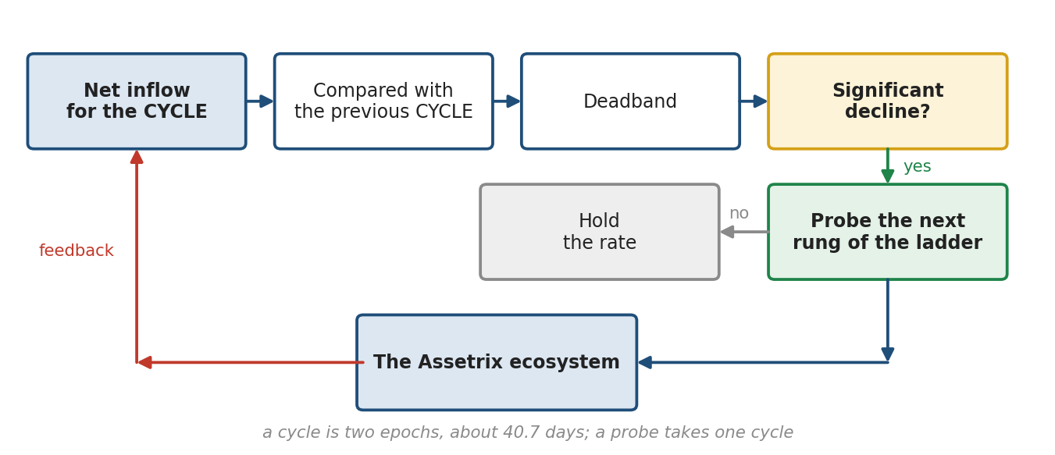
Fig. 7. Growth-rate control loop
Probe | Rate | Explanation
1 | 100 % | step right
2 | 50 % | step left
3 | 161.8 % | two steps right
4 | 38.2 % | two steps left
5 | 23.6 % | right side exhausted, continuing left
6 | 14.5 %
7 | 9 %
8 | 5.6 % | ladder exhausted

The traversal order is shown for a starting position of 61.8 per cent and for a probing that begins with an upward step. When starting from the lowest step — that is, on first activation of the mode and after each reset — probing proceeds upward without retracement to 61.8 per cent, since no steps remain to the left; the 100 and 161.8 per cent steps are not probed on such a start. The ground for this is that one-sided probing is no longer a search: diverging circles test the supposition that the rate is wrong, and six steps in a row in one direction without a response mean the supposition was not borne out.
The value found is retained until the next significant decline in inflow, whereupon probing restarts from the current position without regard to prior experience. Each probe takes one cycle, that is two epochs; the response is determined by comparing the inflow of that cycle with the preceding cycle's. In automatic mode holders vote neither on direction nor on step size.
Probing is limited to a single pass through the ladder, on whichever side it runs and to whichever step it reaches. If inflow has resumed growth at none of the steps, the protocol sets the lowest step and switches to manual mode. Failure of a full pass is a substantive conclusion rather than a malfunction: it means inflow is declining for reasons unrelated to the growth rate. This is the sole case in which the mode switches without a holder vote.

10.4. Cost of probing
The growth rate takes no negative values, so each probe adds to the mint price irreversibly. A full pass through the ladder takes eight probes, roughly 0.89 years, and increases the mint price about 1.38-fold. Probing from the lowest step is shorter — six probes, about 0.67 years and a rise of 1.20-fold; since Phase 2 begins at the lowest step and an exhausted pass returns to it, that is the usual case.
Probe rate | Mint price increase per probe | Duration
5.6 % | 0.61 % | two epochs
23.6 % | 2.38 % | two epochs
61.8 % | 5.49 % | two epochs
161.8 % | 11.29 % | two epochs

Holders should understand that protracted probing itself raises the cost of entry into the protocol, and should have the means to interrupt it — that means being the mode switch.

10.5. Manual mode and switching
In manual mode the regulator is disabled and the growth rate is set directly by vote: a holder votes for a specific rate rather than a shift along the scale, and the median applies. This allows a move to the desired rate within one cycle.
The mode is determined by continuous voting and takes priority over other votes of the cycle. The switch is reversible and may be repeated any number of times. The growth rate in force survives it: handed control back, the regulator resumes its search from the rung it was left on rather than from the bottom of the ladder.
The switch thereby serves as an emergency stop: resorting to it signifies that the prevailing method of control has failed, and control passes to the other side. Resetting the rung along with it would be a price paid for nothing: holders able to carry a vote can hold the rate wherever they like without switching at all, while a community handing control back in good faith would owe six probes of climbing. The protocol contains no separate emergency reset procedure.

10.6. Rhythm and synchronisation
The regular cycle is two epochs. Upon its completion the growth-rate change, fees, the set of collateral currencies, the redemption method and the protection level are applied simultaneously. Simultaneity precludes a situation in which the regulator assesses the result of its own action against a background of otherwise altered conditions.
Measurement always occupies a full cycle. No shortened cycle is provided for: half a cycle carries twice the variance, and a deadband tuned to a full one would begin to fire falsely on it. If the backing protection triggered within a cycle, this is recorded by an event and taken into account in assessing the outcome, but the measurement itself is not shortened.
Epoch and cycle marking operates from the very start of the protocol, including Phase 1, where the regulator is inactive but the cycle serves as the common boundary for all parameter changes. The first epoch begins at contract deployment. The transition to Phase 2 leaves the grid of epochs and cycles untouched: the count continues from deployment, and votes cast in the current cycle are not lost.
The first cycle of Phase 2 is transitional: no base for comparison yet exists and the regulator takes no decisions — the cycle serves as the base for the next. The rate stands at the lowest step of the ladder for that time. The rule applies once, on first entry into Phase 2; on returning from manual mode to automatic there is no transitional cycle, since the preceding cycle was lived independently of the mode. The count of observations for the deadband is not reset on a switch of mode: the history of inflow fluctuation is a property of the market, not of the method of control.
A cycle within which any currency stopped taking deposits — by ban, disconnection or the loss flag — the regulator skips as an unfit base: inflow is measured in dollars deposited, and a currency leaving would read as demand leaving. The history of inflow swings is kept, but that cycle adds nothing to it.

11. Setting of fees
All protocol fees are set by holder vote. There is no automatic tuning, and that was a deliberate choice.
The redemption fee has no optimisation criterion. Redemption is a participant's exit, and maximising the take from those leaving would be the wrong objective. This fee's purpose is to restrain outflow and retain pool volume, and restraint grows with the rate, hence has no maximum.
The transfer fee does have a criterion: the pool's receipts equal the rate times turnover, turnover contracts as the rate rises, and the product has a maximum. Automated search for this maximum was considered and rejected.
The reason is the manipulability of the indicator. Transfers between one's own addresses are indistinguishable from genuine ones, while the fee paid returns to the pool, part of which the payer controls. Doubling turnover for a period costs a participant on the order of fifteen hundred dollars against a thirty-million pool, which suffices to falsify the signal systematically. Voting does not eliminate this manipulability but raises its price roughly three hundredfold, since a vote costs the full backing per token.

Fee | Ladder | Note
On ASTRX transfer | 0 %, 0.0236 %, 0.0382 %, 0.0618 %, 0.1 % | top step 0.1 %
On ASTRX redemption | 0.56 %, 0.9 %, 1.45 %, 2.36 %, 3.82 % | multiplied by the drawdown multiplier
Dilution coefficient | 5.6 %, 9 %, 14.5 %, 23.6 %, 38.2 % | multiplied by the depth of dilution
On closing that raises the floor | Not applicable | prohibited permanently
On position redemption | Not applicable | prohibited permanently

The step between non-zero values in the fee ladders is 1.618 — the same scale as in the ladder of growth rates. The ladder of protection levels and the ladder of growth rates additionally contain the 50 % step, which breaks that ratio: it is included for a smoother movement in the middle of the ladder. For a sense of scale of the transfer rate: at ten transfers a month, 0.1 per cent corresponds to 12.7 per cent a year and 0.0618 per cent to 7.7 per cent.
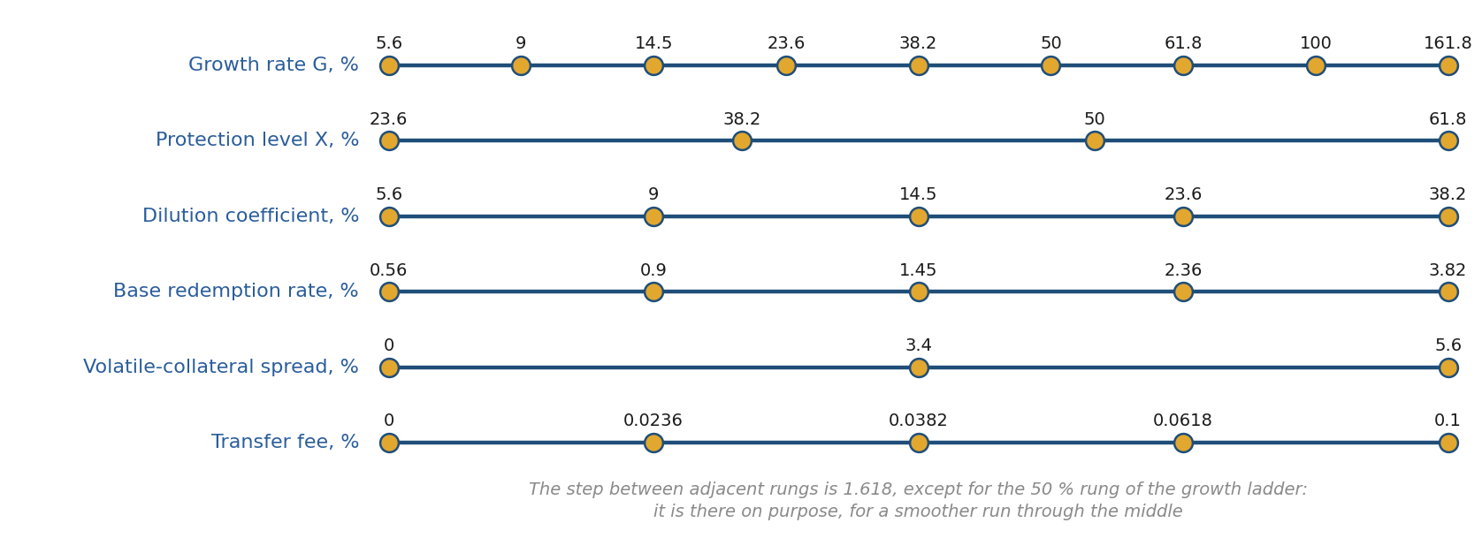
Fig. 8. Unified protocol scale

12. Technical implementation

12.1. Structure and network
A contract's executable code on the network is limited to 24,576 bytes; the protocol's code exceeds that limit more than twofold, so the protocol consists of several contracts. Three boundaries are irreducible. The core — the ASTRX token, the reserve and every operation — fills the limit almost entirely. Positions live apart: the ERC-20 and ERC-721 standards declare a transfer event of the same name, and one contract cannot follow both (§2.1). The quote adapter is separate because quote channels are replaceable and the protocol's logic is not: the core holds the adapter's address immutable, and the operator changes channels inside the adapter (§13.3). The rest — the curve, the regulator, the payout, the surcharge — are computational modules: they hold neither state nor funds; the core asks them and writes the answer itself. The cycle boundary is the one exception and works the other way about: it is a separate contract for room alone, and the core runs it by delegate call, so it executes in the core’s own storage and writes there directly. It holds no funds and no state of its own either, and it declares the same storage layout as the core — a layout the build compares field by field, because a divergence there would be a catastrophe of the kind that is invisible until too late. Their addresses are written into the core at deployment and cannot be replaced; there is no proxy, no upgrade and no manual substitution of modules. Modules may be merged with one another; the final partition is fixed at deployment, does not change afterwards, and is published with the addresses and checksums at https://assetrix.org/documents.
The protocol is deployed on the Arbitrum One layer-two network. The decisive consideration is the cost of an operation to the participant: on Ethereum mainnet the minting fee at early stages would exceed the deposit itself, since the mint price there is measured in fractions of a cent. Development tooling and token standards are identical to mainnet.
The choice of this particular network is determined by the composition of available collateral: all five admitted stablecoins are present on it in meaningful supply, wrapped bitcoin is issued by an independent custodian, and the network operator coincides with none of the collateral issuers.
The canonical instance of the protocol exists in a single copy. The mint price curve, the backing and the circulating supply are global: a second independent deployment would constitute a different asset with its own curve and its own reserve, not the same protocol on another network. Presence on other networks is possible only as a wrapper over the canonical instance, without a second issuance.

The costs of this choice are stated plainly: lower liquidity than mainnet, dependence on the layer-two sequencer, and a less developed retail on-ramp compared with networks tied to exchange applications.

12.2. Curve computation
The Phase 1 mint price curve is defined by a table written at deployment into a separate data blob: 641 nodes, each holding the cumulative capital and the price, and a grid of node positions within a stage of 65 points with denser spacing towards the edges, stored once because the shape of the cycloid is the same for every stage.
The error was measured on the very grid that goes into the contract: 0.00067 per cent by the number of tokens a deposit buys. That is the figure that matters to a participant — an operation executes on the integral of price, not at a point; the error of the price itself, as an interface reading, is 0.045 per cent. No common integral table exists: the shape is one for all stages, but its integral depends on the ratio of a stage’s boundary prices, which differs for each. There are therefore 641 nodes, and the blob occupies about sixteen kilobytes. A uniform grid by token number is unsuitable for this curve: owing to the cycloid's vertical tangent at the stage edge it yields errors of several per cent even with five hundred nodes.

12.3. Data accounting
The protocol's storage holds only the values required for its own operation. Cumulative statistics by operation and currency are not stored in the contract: every operation emits events from which external indexers reconstruct any derived metrics. This substantially reduces the cost of each operation without loss of interface functionality.

12.4. Cost of operations
Computational resource consumption is measured in units of gas. These figures are fixed by the Ethereum protocol and depend neither on price nor on network load: a transaction itself costs 21,000 units, the first write to an unoccupied storage slot 22,100, an update of an occupied one 5,000, a read 2,100. Below is a measurement in a fork of the deployment network with live quote channels, four collateral currencies, steady state; without the base 21,000 per transaction and without the layer-one data fee.
Operation | Gas | Quotes
Position minting | 545,000 | reads, four currencies
Basket redemption, 4 currencies | 420,000 | reads, four currencies
Position closing | 335,000 | reads, four currencies
ASTRX transfer | 77,000 | reads none
Position redemption | 104,000 | reads none
Voting | 87,000 | reads none

Cost in monetary terms depends on network load and the price of ether and is therefore not stated here: on a layer-two network the listed operations cost a few cents, under congestion tens. The cost divides in two: operations that value the reserve read the quote of every collateral currency through external calls, and that is the bulk of what they cost; the exit operations — position redemption, transfer, vote — read no quotes and cost about what an ordinary token transfer does.
The protection check itself is cheap — a few reads and a division; what is dear is the valuation of the reserve it relies on. The redemption fee multiplier requires no new quantities at all: it is the ratio of the already-stored maximum to book backing and reads no quotes.

Applied optimisations
- The mint curve table is deployed as a separate data contract and read by copying code rather than from storage slots: inverting the curve costs 27,500 units instead of the hundreds of thousands that reading six hundred and forty-one pairs of values would take.
- Parameters are recomputed lazily, on the first operation of a new cycle rather than on a schedule: the protocol has no background processes, and the length of a silence does not affect the cost.
- The Phase 2 price is pinned to storage only when the growth rate changes. Between changes it is a pure function of time, and an ordinary operation writes nothing.
- The decision modules are called once per cycle rather than in every operation: splitting the protocol into contracts makes the cycle boundary dearer and ordinary work no dearer at all.
Further reduction would require abandoning checks or the events on which external accounting relies. Such a trade-off is not made: reliability takes priority over cost.

Who bears the cost
Costs are borne by the transaction sender. The protocol pays for nothing and has neither a schedule nor background processes: all time-dependent quantities are computed at the moment of access.
Recomputation at a cycle boundary is performed on the first operation carried out in the new cycle and paid for by whoever performs it; every decision is applied at once, so that minting and redemption never run on rates from different cycles. The surcharge on the first comer is of the order of 250,000 units with two currencies and no announcements; it grows with the number of currencies and with the announcement queue, up to 610,000 with the queue full at twelve. On a layer-two network that is a few cents.

12.5. External data sources
The protocol obtains time from the blockchain itself and does not resort to external sources. At deployment a start timestamp is stored; the current epoch number is computed as the difference between current time and that timestamp divided by the epoch length, and is not stored.
Precision is ample: a discrepancy of several minutes is immaterial given an epoch of twenty days, and the mint price is recomputed continuously with no step at all.
Price data is required wherever the reserve or a deposit is valued: at minting, at position closing, in computing the concentration surcharge, under the most-capitalised method, and in skewing the basket towards a currency on its way out. The exits do without it, a consequence of the design decisions adopted.
- The backing record is kept on the book figure and makes no reference to data sources; the threshold derived from it is brought to the current value of the basket (§8.3).
- The redemption fee multiplier is computed from the ratio of two book quantities.
- Proportional basket redemption pays out pool shares in kind, without conversion into a common currency; it reads quotes only to skew towards a currency on its way out, and does without them when there are none.
- The regulator operates on quantities expressed in dollars at the moment operations occur.

12.6. Security
Standard measures apply: a safe transfer library for correct handling of non-standard ERC-20 implementations, reentrancy protection, and the checks-effects-interactions ordering.
The protocol contains no mechanism for pausing operations. A general pause would be incompatible with the guarantee of section 13: any suspension capable of affecting redemption would render that guarantee fictitious. Restrictions are imposed only on specific grounds and only for specific currencies, under sections 4.4 and 4.5, and never affect the return of funds.

Code mutability
The contract is immutable: no upgrade mechanism, proxy or implementation replacement is provided. The ground is not that trust in any party is inadmissible: the protocol does have roles, and they require trust. The distinction lies elsewhere — the powers of the roles are bounded and reversible, a reserve-loss flag is verified by vote and the operator is replaceable, whereas replacement of the code is irreversible and bounded by nothing. That is why there is none.
The price of immutability is the inability to fix a discovered flaw. It is accepted deliberately and offset by what precedes launch: an independent audit, formal verification of invariants and a bug bounty programme. Changing the protocol is possible only by deploying a new instance and by participants migrating voluntarily.
What remains to a participant should a flaw nonetheless be found. A position is redeemed at face value in the original currency, and this does not depend on whether the protocol is being developed or abandoned; the executability of the transfer itself is determined by the currency issuer and lies beyond the protocol. Tokens are redeemed for a share of the shared pool, and backing per token does not change with others' departure, so the departure of a majority does not devalue those remaining. A new instance inherits neither the curve nor the reserve nor the circulation — it is a different asset. The price of immutability thus consists in a halt to growth and a return at face value, not in a loss of funds.
Prior to deployment, unit, invariant and fuzz testing, static analysis and an independent audit are carried out. After launch a bug bounty programme operates.

13. Boundaries of autonomy

13.1. Guarantee of unimpeded access
A participant's right to recover deposited funds is not restricted under any circumstances. Position redemption returns collateral in full and in the original currency; token redemption pays out a share of the shared pool. No role, no vote and no state of the protocol can halt or defer these operations.

The protocol does not restrict recovery under any circumstances; the executability of a transfer in a given currency is determined by its issuer and lies beyond the protocol's control.
Other operations may be restricted, and this should be stated plainly. A currency ban halts minting and the closing of positions with the corresponding collateral; the rationale is to prevent impaired collateral being shifted onto other holders. The restriction always covers entry and conversion together and never touches recovery.
Fees and surcharges alter the cost of an operation but do not obstruct it. Benchmarks and share limits determine the surcharge and never halt minting at any value. The rule on the minimum number of active currencies addresses the operator and prohibits suspension, not an operation. The backing protection does not prohibit a closing but limits its volume; if the admissible volume falls below the minimum size, the closing is not executed, and redemption, which is limited by nothing, remains available to the participant.

13.2. Roles
The protocol is designed to operate without ongoing administration. Two roles are provided, each in a single instance.

Guardian
The guardian is the holder of the appointment key. Its powers are: appointing the operator by specifying a wallet address, removing the incumbent operator and appointing a new one, and designating the project wallets among which founders' remuneration is distributed. The guardian performs no other actions; in particular it may not suspend the execution of holders' decisions.

Operator
The operator performs all operational actions: setting the current protocol fee rate within the ceiling, announcing collateral currencies for a vote, waking dormant currencies of the launch list, replacing a quote channel in the adapter, and imposing the reserve-loss flag and the currency use ban. The last two take immediate effect and are lifted by the holders by vote.

What no role may do
Alter the mint price, the ladder of growth-rate values, the rules for accruing and distributing backing; introduce a fee on position redemption; admit a currency against the outcome of a vote; or halt or defer the return of funds to participants. Role management is exercised through a multi-signature wallet with time-locked execution.

13.3. What the roles actually do
The powers of the guardian and the operator are described above one by one. Here they are set out as sequences: what is done in each situation, by whom, and in what order. The section is addressed to those who hold the roles and to anyone who wants to know in advance what to expect of them.

Deployment
The contracts are deployed in the order opposite to their dependencies: first the data blob holding the curve table, then the computational modules and the quote adapter, then the positions contract, and last the core — with the addresses of all of those, the sequencer status channel and the list of launch currencies. The payout module the core deploys for itself.
Two wirings are the final steps: the positions contract and the quote adapter each receive the core's address. Each is guarded twice: it runs once, and only for whoever deployed. Left open, the positions wiring would be a gift — a stranger would name himself the core and mint positions out of nothing; an open adapter wiring would hand the quote channels to strangers.
The guardian is set in the core's constructor and receives the first share of the remuneration at the same moment. There is no state without shares: a fee withheld before the first share existed would be beyond anyone's reach for ever.
There is no setup before the protocol opens: the adapter, the sequencer channel and the list of launch currencies with all their properties — issuer, staleness limit, minimum sizes, the stablecoin, volatility and dormancy marks — the core receives at deployment, and it accepts deposits from the first second. Deployment is refused if there are fewer than three currencies or more than twelve, an address repeats, the adapter or a currency is not a contract, or a currency has no price in the adapter.

The guardian
APPOINTING AND REPLACING THE OPERATOR. The guardian appoints the operator and replaces him at any moment, in one action and without a vote. The operator's powers are limited and reversible, so his replacement needs no agreement: everything he can do, the holders can undo by vote.
A NEW PROJECT WALLET. The guardian adds a share in the distribution of the remuneration, naming an address and a weight. There may be no more than a hundred shares. AN ADDED SHARE IS NEVER REMOVED BY ANYONE — not by the guardian, not by a vote, not by its own owner. That is worth knowing before adding one rather than after.
The distribution is settled at the moment the fee is withheld, not at the moment it is paid out. A share added later receives nothing of what was withheld before, including the part earlier owners have yet to claim. What goes unclaimed remains the property of whoever it was credited to.
WHAT THE GUARDIAN CANNOT DO. He does not dispose of the reserve, does not halt redemption, does not change the protocol's parameters, does not repoint the modules and does not replace the code. His powers end with the two above.

The operator
THE PROTOCOL FEE ON ISSUANCE. The operator sets it within the ceiling the stage allows, without a vote. A vote on it would be a pretence: participants always vote for the minimum.
REPLACING A QUOTE CHANNEL. Feeds move and are replaced outright, so the channel address of an admitted currency is replaceable. The replacement is made IN THE ADAPTER, not in the core: the core holds the adapter's address immutable, so the protocol's logic stays fixed and only the pointer to an outside source moves — a source that is beyond the protocol's control in any case.
ANNOUNCING A NEW COLLATERAL CURRENCY. From stage 4 the operator may announce a currency for the connection vote — together with all its properties, on which the holders vote as a whole. The announcement passes checks: the address must be a contract, the currency must have a quote channel and a staleness limit for it, the number of currencies must not exceed twelve, and the same is the limit of the queue of announcements awaiting a cycle boundary. A currency the vote declined, or one disconnected later, may be announced again on fresh terms. A currency is identified by address, not by symbol: two contracts with the symbol USDC exist on the deployment network.
The holders decide from there. The vote runs to the cycle boundary, and at the boundary the presence of a channel is checked again: the source may have fallen away between the announcement and the count. The operator cannot connect a currency — he can only propose one.
WAKING A DORMANT CURRENCY. A currency entered in the launch list dormant begins to accept deposits on a single operator action, without a vote: approval was given in advance by the list itself. The action is made once and is irreversible — nobody can put the currency back to sleep; it can be taken out of circulation by a ban or by a disconnection vote.
BANNING A CURRENCY. If the issuer has frozen addresses, or the currency is compromised in some other way, the operator imposes the ban AT ONCE, without a vote. Waiting would be unreasonable: time passes between the event and its confirmation, and an asset that cannot move must not go on counting as if it could. Under the ban, minting and closing in that currency stop; both redemptions stay open, and the currency is paid out first — the orderly form of its removal. The holders lift the ban by vote, and once lifted the operator may not re-impose it for half a cycle.
THE LOSS FLAG. It is set when the reserve in a currency is genuinely out of reach, not when its price channel has gone quiet. The currency leaves the valuation, the payout and the book value at once; minting and closing in it are barred. The holders lift the flag by vote; it cannot be re-imposed within a day, and if at least a hundred units of that currency have actually left the protocol since the lift, not before the cycle boundary. Something leaving is evidence the reserve was never lost, and re-imposing the flag would look like an attempt to freeze the exit.
A DEAD PRICE CHANNEL is not an occasion for either lever. If the channel has gone quiet while the reserve is where it was, the protocol manages on its own: that currency stops taking deposits and closes, operations in the others carry on as usual, and the state returns by itself as soon as the source answers again. If the channel is dead for good, the operator's proper move is to replace it in the adapter, not to declare a healthy reserve lost.
WHAT THE OPERATOR CANNOT DO. He does not dispose of the reserve, does not halt redemption, does not connect currencies beyond the launch list or disconnect them on his own, does not set the growth rate, the protection level, the dilution coefficient or any other voted parameter, does not repoint the modules and does not replace the code.

The rule behind both
The two emergency levers — the ban and the loss flag — are built the same way: the operator imposes at once, the holders lift by vote, and re-imposition after a lift is barred for a time. The asymmetry is deliberate. The event a lever exists for demands speed, while a mistake in using one should be corrected by those whose money is in the reserve rather than by whoever made it.
Under either flag both exits stay open. That is a requirement rather than a caution: halting minting defers entry, halting closing defers an optional operation, and both are undone by waiting — whereas halting redemption would lock a holder into an asset he has decided to leave, for an unknown time.

14. Metrics and interfaces
The protocol exposes for reading the current mint price, book and market backing per token separately, the historical maximum of book backing and the prevailing protection threshold, aggregate backing by currency and in total, the prevailing phase and stage, the position within the epoch, the prevailing growth rate, the state of open votes and the parameters of any position.
Book and market backing are disclosed separately, since the redemption payout is determined by the market figure while the protection operates on the book figure. Derived statistics are produced by external indexers from the protocol's events.

Disclaimer
This document describes the protocol's design and does not constitute an offer to acquire any asset, investment advice, or a promise of return. The calculations presented were obtained from a model and rest on assumptions stated in place; actual figures will differ.
The timings given in the time model derive from an assumption about capital inflow and constitute neither a forecast nor an undertaking. Operation cost figures depend on network load and the price of ether.
Verification carried out to date. The tokenomics have been modelled in a reference implementation independent of the contract, under a range of holder behaviours: steady inflow, stagnation, mass exit, and deliberate attempts to dilute the pool through splitting and multiple addresses. In every scenario modelled, backing per token held above the protection level and rose over the run. The contract code is covered by a test suite that reproduces the reference implementation’s results and exercises the failure modes the design anticipates: stale or unavailable price feeds, a halted L2 sequencer, loss or de-pegging of a reserve currency, and rounding under adversarial input. Each has a defined response in the code. The suite has been checked by mutation: 225 corruptions of the core’s source, each either caught by the suite or examined and recorded with its reason. These are the project’s own tests; they are disclosed so that they can be repeated, and they precede rather than replace review by others.

Verification
A SHA-256 checksum and an OpenTimestamps proof are published for this document. The checksum establishes that the file you hold is byte-for-byte the one released; the timestamp, anchored in the Bitcoin blockchain, establishes the date on which that exact file existed. Neither requires trusting this project.
Checksums and timestamp proofs for this document: https://assetrix.org/documents
The timestamp proof is distributed as a separate .ots file alongside the document, since a file cannot contain its own checksum. Each revision is listed as a new entry with its own checksum and its own proof; earlier entries are never removed, so the sequence of versions and dates remains visible.

assetrix.org — official website

